Table of Contents

Table of Contents

UNITED STATES

SECURITIES AND EXCHANGE COMMISSION
Washington, D.C. 20549

FORM 10-Q

(Mark One)

- QUARTERLY REPORT PURSUANT TO SECTION 13 OR 15(d) OF THE SECURITIES EXCHANGE ACT OF 1934

For the quarterly period ended March 31, 2021

- TRANSITION REPORT PURSUANT TO SECTION 13 OR 15(d) OF THE SECURITIES EXCHANGE ACT OF 1934

Commission File Number 001-34099

MASTECH DIGITAL, INC.

(Exact name of registrant as specified in its charter)

PENNSYLVANIA | 26-2753540
(State or other jurisdiction of | (I.R.S. Employer
incorporation or organization) | Identification No.)
1305 Cherrington Parkway, Building 210, Suite 400
Moon Township, Pennsylvania | 15108
(Address of principal executive offices) | (Zip Code)

Registrant’s telephone number, including area code: (412) 787-2100

Securities registered pursuant to Section 12(b) of the Act:

Title of each class |  | Trading |  | Name of each exchange
 |  | Symbol(s) |  | on which registered
Common Stock, par value $.01 per share |  | MHH |  | NYSE American

Indicate by check mark whether the registrant (1) has filed all reports required to be filed by Section 13 or 15(d) of the Securities Exchange Act of

1934 during the preceding 12 months (or for such shorter period that the registrant was required to file such reports), and (2) has been subject to such filing requirements for the past 90 days. Yes ☒ No ☐

Indicate by check mark whether the registrant has submitted electronically, every Interactive Data File required to be submitted pursuant to Rule 405 of Regulation S-T (§232.405 of this chapter) during the preceding 12 months (or for such shorter period that the registrant was required to submit such files). Yes ☒ No ☐

Indicate by check mark whether the registrant is a large accelerated filer, an accelerated filer, a non-accelerated filer, a smaller reporting company, or an emerging growth company. See the definitions of “large accelerated filer,” “accelerated filer,” “smaller reporting company,”, and “emerging growth company” in Rule 12b-2 of the Exchange Act.

Large accelerated filer | ☐ | Accelerated filer | ☒
Non-accelerated filer | ☐ | Smaller reporting company | ☒
 |  | Emerging growth company | ☐

If an emerging growth company, indicate by check mark if the registrant has elected not to use the extended transition period for complying with any new or revised financial accounting standards provided pursuant to Section 13(a) of the Exchange Act. ☐

Indicate by check mark whether the registrant is a shell company (as defined in Rule 12b-2 of the Exchange Act). Yes ☐ No ☒

The number of shares of the registrant’s Common Stock, par value $.01 per share, outstanding as of April 30, 2021 was 11,431,052.

Table of Contents

MASTECH DIGITAL, INC.

QUARTERLY REPORT ON FORM 10-Q

FOR THE QUARTER ENDED MARCH 31, 2021

TABLE OF CONTENTS

 |  |  |  |  |  |  |  |  |  |  |  |  |  |  |  |  |  |  |  | Page
PART 1 | FINANCIAL INFORMATION |  |  |  |  |  |  |  |  |  |  |  |  |  |  |  |  |  |  | 3
Item 1. | Financial Statements: |  |  |  |  |  |  |  |  |  |  |  |  |  |  |  |  |  |  | 3
 | (a) Condensed Consolidated Statements of Operations (Unaudited) for the Three Months Ended March 31, 2021 and 2020 |  |  |  |  |  |  |  |  |  |  |  |  |  |  |  |  |  |  | 3
 | (b) Condensed Consolidated Statements of Comprehensive Income (Unaudited) for the Three Months Ended March 31, 2021 and 2020 |  |  |  |  |  |  |  |  |  |  |  |  |  |  |  |  |  |  | 4
 | (c) Condensed Consolidated Balance Sheets (Unaudited) as of March 31, 2021 and December 31, 2020 |  |  |  |  |  |  |  |  |  |  |  |  |  |  |  |  |  |  | 5
 | (d) Condensed Consolidated Statements of Shareholders’ Equity (Unaudited) as of March 31, 2021 and March 31, 2020 |  |  |  |  |  |  |  |  |  |  |  |  |  |  |  |  |  |  | 6
 | (e) Condensed Consolidated Statements of Cash Flows (Unaudited) for the Three Months Ended March 31, 2021 and 2020 |  |  |  |  |  |  |  |  |  |  |  |  |  |  |  |  |  |  | 7
 | (f) Notes to Condensed Consolidated Financial Statements (Unaudited) |  |  |  |  |  |  |  |  |  |  |  |  |  |  |  |  |  |  | 8
Item 2. | Management’s Discussion and Analysis of Financial Condition and Results of Operations |  |  |  |  |  |  |  |  |  |  |  |  |  |  |  |  |  |  | 20
Item 3. | Quantitative and Qualitative Disclosures About Market Risk |  |  |  |  |  |  |  |  |  |  |  |  |  |  |  |  |  |  | 25
Item 4. | Controls and Procedures |  |  |  |  |  |  |  |  |  |  |  |  |  |  |  |  |  |  | 25
PART II | OTHER INFORMATION |  |  |  |  |  |  |  |  |  |  |  |  |  |  |  |  |  |  | 26
Item 1. | Legal Proceedings |  |  |  |  |  |  |  |  |  |  |  |  |  |  |  |  |  |  | 26
Item 1A. | Risk Factors |  |  |  |  |  |  |  |  |  |  |  |  |  |  |  |  |  |  | 26
Item 2. | Unregistered Sales of Equity Securities and Use of Proceeds |  |  |  |  |  |  |  |  |  |  |  |  |  |  |  |  |  |  | 26
Item 6. | Exhibits |  |  |  |  |  |  |  |  |  |  |  |  |  |  |  |  |  |  | 27
 | SIGNATURES |  |  |  |  |  |  |  |  |  |  |  |  |  |  |  |  |  |  | 28
 | 2

Table of Contents

PART I. FINANCIAL INFORMATION

ITEM 1. FINANCIAL STATEMENTS

MASTECH DIGITAL, INC.

CONDENSED CONSOLIDATED STATEMENTS OF OPERATIONS

(Amounts in thousands, except per share data)

(Unaudited)

Three Months Ended
March 31,
 |  | 2021 |  |  |  | 2020
Revenues | $ | 49,775 |  |  | $ | 50,425
Cost of revenues |  | 36,971 |  |  |  | 37,706
Gross profit |  | 12,804 |  |  |  | 12,719
Selling, general and administrative expense |  | 10,935 |  |  |  | 10,243
Income from operations |  | 1,869 |  |  |  | 2,476
Interest income (expense), net |  | (195) |  |  |  | (279)
Other income (expense), net |  | (37) |  |  |  | 53
Income before income taxes |  | 1,637 |  |  |  | 2,250
Income tax expense |  | 443 |  |  |  | 381
Net income | $ | 1,194 |  |  | $ | 1,869
Earnings Per Share:
Basic | $ | .10 |  |  | $ | .17
Diluted | $ | .10 |  |  | $ | .16
Weighted average common shares outstanding:
Basic |  | 11,415 |  |  |  | 11,127
Diluted |  | 11,997 |  |  |  | 11,675

The accompanying notes are an integral part of these Condensed Consolidated Financial Statements.

3

Table of Contents

MASTECH DIGITAL, INC.

CONDENSED CONSOLIDATED STATEMENTS OF COMPREHENSIVE INCOME

(Amounts in thousands)

(Unaudited)

Three Months Ended
March 31,
 |  | 2021 |  |  |  |  | 2020
Net income |  | $ 1,194 |  |  |  | $ | 1,869
Other comprehensive income (loss):
Net unrealized gain (loss) on interest-rate swap contracts | 35 |  |  |  |  |  | (94)
Foreign currency translation adjustments |  | (19) |  |  |  |  | (267)
Total pretax net unrealized gain (loss) |  | 16 |  |  |  |  | (361)
Income tax expense (benefit) |  | 9 |  |  |  |  | (25)
Total other comprehensive gain (loss), net of taxes |  | 7 |  |  |  |  | (336)
Total comprehensive income |  | $ 1,201 |  |  |  | $ | 1,533

The accompanying notes are an integral part of these Condensed Consolidated Financial Statements.

4

Table of Contents

MASTECH DIGITAL, INC.

CONDENSED CONSOLIDATED BALANCE SHEETS

(Amounts in thousands, except share and per share data)

(Unaudited)

 |  | March 31, |  |  |  | December 31,
 |  |  | 2021 |  |  |  | 2020
ASSETS
Current assets:
Cash and cash equivalents | $ |  | 7,242 |  |  | $ | 7,677
Accounts receivable, net of allowance for uncollectible accounts of $426 in 2021 and $413 in 2020 |  |  | 23,425 |  |  |  | 22,036
Unbilled receivables |  |  | 12,781 |  |  |  | 10,098
Prepaid and other current assets |  |  | 1,238 |  |  |  | 1,346
Total current assets |  |  | 44,686 |  |  |  | 41,157
Equipment, enterprise software, and leasehold improvements, at cost:
Equipment |  |  | 2,055 |  |  |  | 1,931
Enterprise software |  |  | 2,730 |  |  |  | 2,730
Leasehold improvements |  |  | 563 |  |  |  | 563
 |  |  | 5,348 |  |  |  | 5,224
Less – accumulated depreciation and amortization |  |  | (3,453) |  |  |  | (3,253)
Net equipment, enterprise software, and leasehold improvements |  |  | 1,895 |  |  |  | 1,971
Operating lease right-of-use assets |  |  | 3,199 |  |  |  | 3,286
Deferred income taxes |  |  | 804 |  |  |  | 796
Non-current deposits |  |  | 459 |  |  |  | 396
Goodwill, net of impairment |  |  | 32,510 |  |  |  | 32,510
Intangible assets, net of amortization |  |  | 21,137 |  |  |  | 21,930
Total assets |  | $ | 104,690 |  |  | $ | 102,046
LIABILITIES AND SHAREHOLDERS’ EQUITY
Current liabilities:
Current portion of long-term debt | $ |  | 4,400 |  |  | $ | 4,400
Accounts payable |  |  | 3,915 |  |  |  | 2,589
Accrued payroll and related costs |  |  | 12,882 |  |  |  | 12,374
Current portion of operating lease liability |  |  | 1,056 |  |  |  | 1,079
Other accrued liabilities |  |  | 1,166 |  |  |  | 1,051
Deferred revenue |  |  | 405 |  |  |  | 478
Total current liabilities |  |  | 23,824 |  |  |  | 21,971
Long-term liabilities:
Long-term debt, less current portion, net |  |  | 11,795 |  |  |  | 12,875
Contingent consideration liability |  |  | 2,882 |  |  |  | 2,882
Long-term operating lease liability, less current portion |  |  | 2,273 |  |  |  | 2,325
Long-term accrued income taxes |  |  | 165 |  |  |  | 165
Long-term payroll tax liabilities |  |  | 2,295 |  |  |  | 2,295
Total liabilities |  |  | 43,234 |  |  |  | 42,513
Commitments and contingent liabilities (Note 6)
Shareholders’ equity:
Preferred Stock, no par value; 20,000,000 shares authorized; none outstanding |  |  | — |  |  |  | —
Common Stock, par value $.01; 250,000,000 shares authorized and 13,076,972 shares issued as of March 31, 2021
and 13,039,893 shares issued as of December 31, 2020 |  |  | 130 |  |  |  | 130
Additional paid-in-capital |  |  | 26,231 |  |  |  | 25,509
Retained earnings |  |  | 39,814 |  |  |  | 38,620
Accumulated other comprehensive income (loss) |  |  | (532) |  |  |  | (539)
Treasury stock, at cost; 1,646,420 shares as of March 31, 2021 and as of December 31, 2020 |  |  | (4,187) |  |  |  | (4,187)
Total shareholders’ equity |  |  | 61,456 |  |  |  | 59,533
Total liabilities and shareholders’ equity |  | $ | 104,690 |  |  | $ | 102,046

The accompanying notes are an integral part of these Condensed Consolidated Financial Statements.

5

Table of Contents

MASTECH DIGITAL, INC.

CONDENSED CONSOLIDATED STATEMENTS OF SHAREHOLDERS’ EQUITY

(Amounts in thousands)

(Unaudited)

 |  |  |  |  |  | Additional |  |  | Accumulated |  |  |  |  |  |  | Accumulated |  |  |  | Total
 |  | Common |  |  |  |  |  |  |  |  |  |  | Treasury |  |  |  | Other
 |  |  |  |  |  | Paid-in |  |  |  | Retained |  |  |  |  |  | Comprehensive |  |  | Shareholders’
 |  |  | Stock |  |  | Capital |  |  |  | Earnings |  |  | Stock |  |  | Income (Loss) |  |  |  | Equity
Balances, December 31, 2020 |  | $ | 130 |  |  | $ 25,509 |  |  | $ | 38,620 |  |  | $(4,187) |  |  | $ | (539) |  | $ | 59,533
Net income |  |  | — |  |  | — |  |  |  | 1,194 |  |  | — |  |  |  | — |  |  | 1,194
Other comprehensive gain, net of taxes |  |  | — |  |  | — |  |  |  | — |  |  | — |  |  |  | 7 |  |  | 7
Stock-based compensation expense |  |  | — |  | 621 |  |  |  |  | — |  |  | — |  |  |  | — |  |  | 621
Stock options exercised |  |  | — |  | 101 |  |  |  |  | — |  |  | — |  |  |  | — |  |  | 101
Balances, March 31, 2021 |  | $ | 130 |  |  | $ 26,231 |  |  | $ | 39,814 |  |  | $(4,187 | ) |  | $ | (532) |  | $ | 61,456
 |  |  |  |  |  | Additional |  |  | Accumulated |  |  |  |  |  |  | Accumulated |  |  |  | Total
 |  | Common |  |  |  |  |  |  |  |  |  |  | Treasury |  |  |  | Other
 |  |  |  |  |  | Paid-in |  |  |  | Retained |  |  |  |  |  | Comprehensive |  |  | Shareholders’
 |  |  | Stock |  |  | Capital |  |  |  | Earnings |  |  | Stock |  |  | Income (Loss) |  |  |  | Equity
Balances, December 31, 2019 |  | $ | 127 |  |  | $ 21,939 |  |  | $ | 28,759 |  |  | $(4,187) |  |  | $ | (358) |  | $ | 46,280
Net income |  |  | — |  |  | — |  |  |  | 1,869 |  |  | — |  |  |  | — |  |  | 1,869
Other comprehensive (loss), net of taxes |  |  | — |  |  | — |  |  |  | — |  |  | — |  |  |  | (336) |  |  | (336)
Stock-based compensation expense |  |  | — |  | 456 |  |  |  |  | — |  |  | — |  |  |  | — |  |  | 456
Stock options exercised |  |  | 1 |  | 555 |  |  |  |  | — |  |  | — |  |  |  | — |  |  | 556
Balances, March 31, 2020 |  | $ | 128 |  |  | $ 22,950 |  |  | $ | 30,628 |  |  | $(4,187 | ) |  | $ | (694) |  | $ | 48,825

The accompanying notes are an integral part of these Condensed Consolidated Financial Statements.

6

Table of Contents

MASTECH DIGITAL, INC.

CONDENSED CONSOLIDATED STATEMENTS OF CASH FLOWS

(Amounts in thousands)

(Unaudited)

Three Months Ended
March 31,
 |  | 2021 |  |  |  |  | 2020
OPERATING ACTIVITIES:
Net income | $ 1,194 |  |  |  | $ |  | 1,869
Adjustments to reconcile net income to cash provided by (used in) operating activities:
Depreciation and amortization | 997 |  |  |  |  |  | 873
Interest amortization of deferred financing costs | 20 |  |  |  |  |  | 26
Stock-based compensation expense | 621 |  |  |  |  |  | 456
Deferred income taxes, net | (8) |  |  |  |  |  | (182)
Operating lease assets and liabilities, net | 12 |  |  |  |  |  | (37)
Loss on disposition of fixed assets |  | — |  |  |  |  | 2
Working capital items:
Accounts receivable and unbilled receivables | (4,072) |  |  |  |  |  | (1,244)
Prepaid and other current assets | 108 |  |  |  |  |  | 492
Accounts payable | 1,326 |  |  |  |  |  | (587)
Accrued payroll and related costs | 508 |  |  |  |  |  | 1,554
Other accrued liabilities | 141 |  |  |  |  |  | (276)
Deferred revenue |  | (73) |  |  |  |  | (151)
Net cash flows provided by operating activities |  | 774 |  |  |  |  | 2,795
INVESTING ACTIVITIES:
Recovery of (payment for) non-current deposits | (63) |  |  |  |  |  | 17
Capital expenditures |  | (128) |  |  |  |  | (119)
Net cash flows (used in) investing activities |  | (191) |  |  |  |  | (102)
FINANCING ACTIVITIES:
(Repayments) borrowings on revolving credit facility, net |  | — |  |  |  |  | (2,244)
(Repayments) on term loan facility | (1,100) |  |  |  |  |  | (1,144)
Proceeds from exercise of stock options | 101 |  |  |  |  |  | 556
Net cash flows (used in) financing activities |  | (999) |  |  |  |  | (2,832)
Effect of exchange rate changes on cash and cash equivalents | (19) |  |  |  |  |  | (267)
Net change in cash and cash equivalents |  | (435) |  |  |  |  | (406)
Cash and cash equivalents, beginning of period | 7,677 |  |  |  |  |  | 2,981
Cash and cash equivalents, end of period |  | $ 7,242 |  |  |  | $ | 2,575

The accompanying notes are an integral part of these Condensed Consolidated Financial Statements.

7

Table of Contents

MASTECH DIGITAL, INC.

NOTES TO CONDENSED CONSOLIDATED FINANCIAL STATEMENTS

MARCH 31, 2021 AND 2020

(Unaudited)

- Description of Business and Basis of Presentation: Basis of Presentation

References in this Quarterly Report on Form 10-Q to “we”, “our”, “Mastech Digital”, “Mastech” or “the Company” refer collectively to Mastech Digital, Inc. and its wholly-owned operating subsidiaries, which are included in these Condensed Consolidated Financial Statements (the “Financial Statements”).

Description of Business

We are a provider of Digital Transformation IT Services to mostly large and medium-sized organizations.

Our portfolio of offerings includes data management and analytics services; digital learning services; and IT staffing services.

Reflective of our 2017 acquisition of the services division of Canada-based InfoTrellis, Inc., we have added specialized capabilities in delivering data and analytics services to our customers globally. This business offers project-based consulting services in the areas of data management, data engineering and data science, with such services delivered using on-site and offshore resources. In October 2020, we acquired AmberLeaf Partners, Inc. (“AmberLeaf”), a Chicago-based customer experience consulting firm. This acquisition expanded our capabilities in customer experience strategy and managed services offering for a variety of Cloud-based enterprise applications across sales, marketing and customer services organizations.

Our IT staffing business combines technical expertise with business process experience to deliver a broad range of staffing services in digital and mainstream technologies. Our digital technologies include data management, analytics, cloud, mobility, social and artificial intelligence. We work with businesses and institutions with significant IT spending and recurring staffing service needs. We also support smaller organizations with their “project focused” temporary IT staffing requirements.

The COVID-19 pandemic had a material impact on activity levels in both of our business segments in 2020. During the first quarter of 2021, we are encouraged by the global roll-out of vaccination programs and some signs of economic expansion and improving economic conditions as the impact of the pandemic subsides. There is, however, still uncertainty regarding the pace, nature and extent of the recovery of global markets and particular industries from the pandemic.

Accounting Principles

The accompanying Financial Statements have been prepared by management in accordance with U.S. generally accepted accounting principles (“GAAP”) for interim financial information and applicable rules and regulations of the Securities and Exchange Commission (the “SEC”). Accordingly, they do not include all of the information and disclosures required by U.S. GAAP for complete consolidated financial statements. In the opinion of management, all adjustments, consisting principally of normal recurring adjustments, considered necessary for a fair presentation have been included. The preparation of financial statements in conformity with U.S. GAAP requires management to make estimates and assumptions that affect the amounts reported in the Financial Statements and the accompanying notes. Actual results could differ from these estimates. These Financial Statements should be read in conjunction with the Company’s audited consolidated financial statements and accompanying notes for the year ended December 31, 2020, included in our Annual Report on Form 10-K filed with the SEC on March 16, 2021. Additionally, our operating results for the three months ended March 31, 2021 are not necessarily indicative of the results that can be expected for the year ending December 31, 2021 or for any other period.

Principles of Consolidation

The Financial Statements include the accounts of the Company and its wholly-owned subsidiaries. All material intercompany transactions and balances have been eliminated in consolidation.

Critical Accounting Policies

Please refer to Note 1 “Summary of Significant Accounting Policies” of the Consolidated Financial Statements and “Management’s Discussion and Analysis of Financial Condition and Results of Operations–Critical Accounting Policies and Estimates” in our Annual Report on Form 10-K for the year ended December 31, 2020 for a more detailed discussion of our significant accounting policies and critical accounting estimates. There were no material changes to these critical accounting policies during the three months ended March 31, 2021.

8

Table of Contents

Segment Reporting

The Company has two reportable segments, in accordance with Accounting Standards Committee (“ASC”) Topic 280 “Disclosures About Segments of an Enterprise and Related Information”: Data and Analytics Services and IT Staffing Services.

- Revenue from Contracts with Customers

The Company recognizes revenue on time-and-material contracts over time as services are performed and expenses are incurred. Time-and-material contracts typically bill at an agreed-upon hourly rate, plus out-of-pocket expense reimbursement. Out-of-pocket expense reimbursement amounts vary by assignment, but on average represent less than 2% of total revenues. Revenue is earned on a per transaction or labor hour basis, as that amount directly corresponds to the value of the Company’s performance. Revenue recognition is negatively impacted by holidays and consultant vacation and sick days.

The Company recognizes revenue on fixed price contracts over time as services are rendered and uses a cost-based input method to measure progress. Determining a measure of progress requires management to make judgments that affect the timing of revenue recognized. Under the cost-based input method, the extent of progress towards completion is measured based on the ratio of costs incurred to date to the total estimated costs at completion of the performance obligation. Revenues, including estimated fees or profits, are recorded proportionally as costs are incurred. The Company has determined that the cost-based input method provides a faithful depiction of the transfer of goods or services to the customer. Estimated losses are recognized immediately in the period in which current estimates indicate a loss. We record deferred revenues when cash payments are received or due in advance of our performance, including amounts which may be refundable.

The Company’s time-and-material and fixed price revenue streams are recognized over time as the customer receives and consumes the benefits of the Company’s performance as the work is performed.

In certain situations related to client direct hire assignments, where the Company’s fee is contingent upon the hired resources continued employment with the client, revenue is not fully recognized until such employment conditions are satisfied.

We do not sell, lease or otherwise market computer software or hardware, and essentially 100% of our revenue is derived from the sale of data and analytics, IT staffing and digital transformation services. We expense sales commissions in the same period in which revenues are realized. These costs are recorded within sales and marketing expenses.

Each contract the Company enters into is assessed to determine the promised services to be performed and includes identification of the performance obligations required by the contract. In substantially all of our contracts, we have identified a single performance obligation for each contract either because the promised services are distinct or the promised services are highly interrelated and interdependent and therefore represent a combined single performance obligation.

Our Data and Analytics Services segment provides specialized capabilities in delivering data management and analytics services to customers globally. This business offers project-based consulting services in the areas of Master Data Management, Enterprise Data Integration, Data Engineering and Analytics, which can be delivered using onsite and offshore resources.

Our IT Staffing Services segment combines technical expertise with business process experience to deliver a broad range of services in digital and mainstream technologies. Our digital technology stack includes data management and analytics, cloud, mobility, social and automation. Our mainstream technologies include business intelligence / data warehousing; web services; enterprise resource planning & customer resource management; and e-Business solutions. We work with businesses and institutions with significant IT spend and recurring staffing needs. We also support smaller organizations with their “project focused” temporary IT staffing requirements.

9

Table of Contents

The following table depicts the disaggregation of our revenues by contract type and operating segment:

Three Months Ended
March 31,
 |  |  |  |  | 2021 |  |  | 2020
 |  |  |  |  | (Amounts in thousands)
Data and Analytics Services Segment
Time-and-material Contracts |  |  | $ |  | 5,854 |  | $ | 4,127
Fixed-price Contracts |  |  |  |  | 2,940 |  |  | 3,233
Subtotal Data and Analytics Services |  |  |  | $ | 8,794 |  | $ | 7,360
IT Staffing Services Segment
Time-and-material Contracts |  |  | $ |  | 40,981 |  | $ | 43,065
Fixed-price Contracts |  |  |  |  | — |  |  | —
Subtotal IT Staffing Services |  |  |  | $ | 40,981 |  | $ | 43,065
Total Revenues |  |  | $ |  | 49,775 |  | $ | 50,425

For the three months ended March 31, 2021, the Company had one client (CGI = 15%) that exceeded 10% of total revenues. For the three months ended March 31, 2020, the Company had the same one client (CGI = 12.7%) that exceeded 10% of total revenues.

The Company’s top ten clients represented approximately 47% and 46% of total revenues for the three months ended March 31, 2021 and 2020, respectively.

The following table presents our revenue from external customers disaggregated by geography, based on the work location of our customers:

Three Months Ended
March 31,
 |  | 2021 |  |  |  | 2020
 |  | (Amounts in thousands)
United States | $ 47,942 |  |  |  | $ | 49,350
Canada | 1,264 |  |  |  |  | 861
India and other | 569 |  |  |  |  | 214
Total |  | $ 49,775 |  |  | $ | 50,425

- Business Combinations

On October 1, 2020, Mastech Digital, Inc., through its wholly-owned subsidiary Mastech Digital Data, Inc., acquired all of the outstanding shares of AmberLeaf Partners, Inc. (“AmberLeaf”). Under the terms of the Share Purchase Agreement executed in connection with the AmberLeaf acquisition (the “Purchase Agreement”), the Company paid at the closing of the acquisition approximately $9.7 million in cash. The Purchase Agreement also requires the Company to pay to the former shareholders of AmberLeaf up to $4.5 million in deferred cash payments, which payments are contingent upon the AmberLeaf business achieving specific revenue growth and EBITDA margin targets. The amount of these deferred cash payments, if any, is based upon the revenue growth and EBITDA margins of the AmberLeaf business for the 12-month period beginning on January 1, 2021 and for the 12-month period beginning January 1, 2022, as described more fully in the Purchase Agreement.

To fund the acquisition, on October 1, 2020 the Company entered into a Third Amendment (the “Third Amendment”) to its Credit Agreement, as amended and dated April 20, 2018. The Third Amendment amends the Credit Agreement by, among other things, (1) increasing the aggregate commitment amount of the revolving credit facility to $30 million (an increase of $7.5 million); (2) providing for the Term Loan facility in the aggregate amount of $17.5 million (an increase of $10 million); (3) providing for an increase in the total commitment amount to the facility in an aggregate amount not to exceed $15 million, upon the satisfaction of certain conditions; and (4) amending the financial covenant in the Credit Agreement related to the Company’s Fixed Charge Coverage Ratio (as defined in the Credit Agreement) by increasing the minimum permitted Fixed Charge Coverage Ratio for each of the fiscal quarters ending on or after September 30, 2020.

10

Table of Contents

The acquisition was accounted for using the acquisition method of accounting. The acquisition method of accounting requires that the assets acquired and liabilities assumed be measured at their fair value as of the closing date.

The following table summarizes the fair value of consideration for the acquired business on the October 1, 2020 closing date:

(in thousands) |  |  | Amounts
Cash purchase price at closing |  |  | $ | 9,664
Working capital adjustments |  |  |  | —
Estimated payout of contingent consideration (1) |  |  |  | 2,882
Total Fair Value of Consideration |  |  | $ | 12,546

- Based on a valuation conducted by an independent third party, the fair value of contingent consideration at the closing date was determined to be $2,882,000.

The cash purchase price at closing was paid with funds obtained from the following sources:

(in thousands) |  |  | Amounts
Cash balances on hand |  |  | $ | —
Increase in term loan debt facility |  |  |  | 10,000
Revolving line of credit |  |  |  | (336)
Cash Paid at Closing |  |  | $ | 9,664

The allocation of the purchase price was based on estimates of the fair value of assets acquired and liabilities assumed as of October 1, 2020, as set forth below. The excess purchase price over the fair values of the net tangible assets and identifiable intangible assets was recorded as goodwill, which includes value associated with the assembled workforce. Goodwill is expected to be largely deductible for tax purposes. The valuation of net assets acquired is as follows:

(in thousands) |  |  | Amounts
Cash on hand |  |  | $ | 319
Working capital assets, net of liabilities |  |  |  | 1,153
Identifiable intangible assets:
Client relationships |  |  |  | 2,970
Covenant not-to-compete |  |  |  | 440
Trade name |  |  |  | 490
Technology |  |  |  | 770
Total identifiable intangible assets |  |  |  | 4,670
Goodwill |  |  |  | 6,404
Net Assets Acquired |  |  | $ | 12,546

The fair value of identifiable intangible assets has been estimated using the income approach through a discounted cash flow analysis. Specifically, the Company used the income approach through an excess earnings analysis to determine the fair value of client relationships. The value applied to the covenant not-to-compete was based on an income approach using a “with or without” analysis of this covenant in place. The trade name and technology were valued using the income approach—relief from royalty method. All identifiable intangibles are considered level 3 inputs under the fair value measurement and disclosure guidance.

The Company incurred $650,000 of transaction expenses related to the acquisition in 2020 inclusive of the write-off of $185,000 of deferred finance costs. No transaction costs were incurred for the three months ended March 31, 2021 and 2020.

Included in the Condensed Statement of Operations for the three months ended March 31, 2021 are revenues of $1.9 million and a net loss of approximately $0.1 million applicable to the AmberLeaf operations acquired on October 1, 2020.

11

Table of Contents

The following reflects the Company’s unaudited pro forma results had the results of AmberLeaf been included for all periods presented:

 |  |  | Three Months Ended March 31,
 |  |  | 2021 |  |  | 2020
(Amounts in thousands, except per share data) |  |  | Actual |  |  | Pro Forma
Revenue | $ |  | 49,775 |  | $ | 53,634
Net income | $ |  | 1,194 |  | $ | 2,337
Earnings per share—diluted | $ |  | .10 |  | $ | .20

The information above does not reflect all of the operating efficiencies or inefficiencies that may have resulted from the AmberLeaf acquisition in those periods prior to the acquisition. Therefore, the unaudited pro forma information above is not necessarily indicative of results that would have been achieved had the business been combined during all periods presented.

- Goodwill and Other Intangible Assets, net

Goodwill related to our June 15, 2015 acquisition of Hudson Global Resources Management’s U.S. IT staffing business (“Hudson IT”) totaled $8.4 million. Goodwill related to our July 13, 2017 acquisition of the services division of InfoTrellis totaled $27.4 million. Goodwill related to our October 1, 2020 acquisition of AmberLeaf totaled $6.4 million.

The Company is amortizing the identifiable intangible assets on a straight-line basis over estimated average lives ranging from 3 to 12 years.

Identifiable intangible assets were comprised of the following as of March 31, 2021 and December 31, 2020:

 |  |  |  |  | As of March 31, 2021
(Amounts in thousands) |  | Amortization |  | Gross Carrying |  |  |  | Accumulative |  |  | Net Carrying
 |  | Period (In Years) |  |  | Value |  |  | Amortization |  |  |  | Value
IT Staffing Services:
Client relationships |  | 12 |  | $ | 7,999 |  |  | $ | 3,861 |  | $ | 4,138
Covenant-not-to-compete |  | 5 |  |  | 319 |  |  |  | 319 |  |  | —
Trade name |  | 3 |  |  | 249 |  |  |  | 249 |  |  | —
Data and Analytics Services:
Client relationships |  | 12 |  |  | 19,641 |  |  |  | 5,274 |  |  | 14,367
Covenant-not-to-compete |  | 5 |  |  | 1,201 |  |  |  | 608 |  |  | 593
Trade name |  | 5 |  |  | 1,711 |  |  |  | 956 |  |  | 755
Technology |  | 7 |  |  | 1,979 |  |  |  | 695 |  |  | 1,284
Total Intangible Assets |  |  |  | $ | 33,099 |  |  | $ | 11,962 |  | $ | 21,137
 |  |  |  |  | As of December 31, 2020
(Amounts in thousands) |  | Amortization |  | Gross Carrying |  |  |  | Accumulative |  |  | Net Carrying
 |  | Period (In Years) |  |  | Value |  |  | Amortization |  |  |  | Value
IT Staffing Services:
Client relationships |  | 12 |  | $ | 7,999 |  |  | $ | 3,694 |  | $ | 4,305
Covenant-not-to-compete |  | 5 |  |  | 319 |  |  |  | 319 |  |  | —
Trade name |  | 3 |  |  | 249 |  |  |  | 249 |  |  | —
Data and Analytics Services:
Client relationships |  | 12 |  |  | 19,641 |  |  |  | 4,866 |  |  | 14,775
Covenant-not-to-compete |  | 5 |  |  | 1,201 |  |  |  | 548 |  |  | 653
Trade name |  | 5 |  |  | 1,711 |  |  |  | 869 |  |  | 842
Technology |  | 7 |  |  | 1,979 |  |  |  | 624 |  |  | 1,355
Total Intangible Assets |  |  |  | $ | 33,099 |  |  | $ | 11,169 |  | $ | 21,930

Amortization expense for the three months ended March 31, 2021 and 2020 totaled $793,000 and $673,000, respectively and is included in selling, general and administrative expenses in the Condensed Consolidated Statement of Operations.

12

Table of Contents

The estimated aggregate amortization expense for intangible assets for the years ending December 31, 2021 through 2025 is as follows:

 |  |  | Years Ended December 31,
 |  | 2021 | 2022 | 2023 | 2024 | 2025
 |  |  | (Amounts in thousands)
Amortization expense | $3,168 |  | $2,987 | $2,772 | $2,693 | $2,553

- Leases

The Company rents certain office facilities and equipment under noncancelable operating leases. As of March 31, 2021, approximately 82,000 square feet of office space is utilized for our sales and recruiting offices, delivery centers, and corporate headquarters. All of our leases are classified as operating leases. The average initial lease term is four years. Several leases have an option to renew, at our sole discretion, for an additional term. Our present lease terms range from less than one year to 5.3 years with an average of 2.1 years. Leases with an initial term of twelve months or less are not recorded on the balance sheet.

The following table summarizes the balance sheet classification of the lease assets and related lease liabilities:

 |  | March 31, 2021 |  |  |  | December 31, 2020
 |  |  |  |  | ( in thousands)
Assets:
Long-term operating lease right-of-use assets | $ |  | 3,199 |  | $ |  | 3,286
Liabilities:
Short-term operating lease liability | $ |  | 1,056 |  | $ |  | 1,079
Long-term operating lease liability |  |  | 2,273 |  |  |  | 2,325
Total liabilities |  | $ | 3,329 |  |  | $ | 3,404

Future minimum rental payments for office facilities and equipment under the Company’s noncancelable operating leases are as follows:

 |  | Amount as of
 |  | March 31, 2021
 |  | (in thousands)
 | 2021 (For remainder of year) | $ | 888
 | 2022 |  | 1,187
 | 2023 |  | 1,139
 | 2024 |  | 339
 | 2025 |  | 52
 | Thereafter |  | 30
 | Total |  | 3,635
 | Less: Imputed interest |  | (306)
 | Present value of operating lease liabilities | $ | 3,329

The weighted average discount rate used to calculate the present value of future lease payments was 5.2%.

We recognize rent expense for these leases on a straight-line basis over the lease term. Rental expense for the three months ended March 31, 2021 and 2020 totaled $0.4 million and $0.4 million, respectively.

Total cash paid for lease liabilities for the three months ended March 31, 2021 and 2020 totaled $0.4 million and $0.4 million, respectively.

New leases entered into during the three months ended March 31, 2021 and 2020 totaled $0.3 million and $0.2 million, respectively.

13

Table of Contents

On April 1, 2021, the Company entered into a three year operating lease for 35,356 square feet of office space in Chennai, India. This lease replaces the Company’s existing 19,120 square foot lease. Lease payments over the three year period will approximate $1.4 million in the aggregate. The lease is renewable for two additional three-year terms with a 15% increase in rent.

- Commitments and Contingencies

In the ordinary course of our business, the Company is involved in a number of lawsuits and administrative proceedings. While uncertainties are inherent in the final outcome of these matters, the Company’s management believes, after consultation with legal counsel, that the disposition of these proceedings should not have a material adverse effect on our financial position, results of operations or cash flows.

- Employee Benefit Plan

The Company provides an Employee Retirement Savings Plan (the “Retirement Plan”) under Section 401(k) of the Internal Revenue Code of 1986, as amended (the “Code”), that covers substantially all U.S. based salaried and W-2 hourly employees. Employees may contribute a percentage of eligible compensation to the Retirement Plan, subject to certain limits under the Code. The Company did not provide for any matching contributions for the three months ended March 31, 2021 and 2020.

- Stock-Based Compensation

In 2008, the Company adopted a Stock Incentive Plan (the “Plan”) which, as amended, provides that up to 4,900,000 shares of the Company’s Common Stock shall be allocated for issuance to directors, officers and key personnel. Grants under the Plan can be made in the form of stock options, stock appreciation rights, performance shares or stock awards. During the three months ended March 31, 2021, the Company granted restricted share units of 11,955 and 270,000 stock option grants at an average strike price of $17.65. During the three months ended March 31, 2020, the Company granted 11,475 restricted share units and 800,000 stock options at a strike price of $15.49 under the Plan. As of March 31, 2021 there were 339,000 shares available for grants under the Plan.

Stock-based compensation expense for the three months ended March 31, 2021 and 2020 was $621,000 and $456,000, respectively, and is included in selling, general and administrative expenses in the Condensed Consolidated Statements of Operations.

During the three months ended March 31, 2021 and 2020, the Company issued 29,739 and 141,066 shares, respectively, related to the vesting of restricted shares and the exercising of stock options.

In October 2018, the Board of Directors of the Company approved the Mastech Digital, Inc. 2019 Employee Stock Purchase Plan (the “Stock Purchase Plan”). The Stock Purchase Plan is intended to meet the requirements of Section 423 of the Code and was approved by the Company’s shareholders to be qualified. On May 15, 2019, the Company’s shareholders approved the Stock Purchase Plan. Under the Stock Purchase Plan, 600,000 shares of Common Stock (subject to adjustment upon certain changes in the Company’s capitalization) are available for purchase by eligible employees who become participants in the Stock Purchase Plan. The purchase price per share is 85% of the lesser of (i) the fair market value per share of Common Stock on the first day of the offering period, or (ii) the fair market value per share of Common Stock on the last day of the offering period.

The Company’s eligible full-time employees are able to contribute up to 15% of their base compensation into the employee stock purchase plan, subject to an annual limit of $25,000 per person. Employees are able to purchase Company common stock at a 15% discount to the lower of the fair market value of the Company’s common stock on the initial or final trading dates of each six-month offering period. Offering periods begin on January 1 and July 1 of each year. The Company uses the Black-Scholes option pricing model to determine the fair value of employee stock purchase plan share-based payments. The fair value of the six-month “look-back” option in the Company’s employee stock purchase plans is estimated by adding the fair value of 15% of one share of stock to 85% of the fair value of an option on one share of stock. The Company utilized U.S. Treasury yields as of the grant date for its risk-free interest rate assumption, matching the Treasury yield terms to the six-month offering period. The Company utilized historical company data to develop its dividend yield and expected volatility assumptions.

During the three months ended March 31, 2021 and 2020, there were no shares issued under the Stock Purchase Plan. At March 31, 2021, there were 539,041 shares available for purchases under the Plan.

- Credit Facility

On July 13, 2017, the Company entered into a Credit Agreement (the “Credit Agreement”) with PNC Bank, as administrative agent, swing loan lender and issuing lender, PNC Capital Markets LLC, as sole lead arranger and sole book-runner, and certain financial institution parties thereto as lenders (the “Lenders”). The Credit Agreement, as amended, provides for a total aggregate commitment of $47.5 million, consisting of (i) a revolving credit facility (the “Revolver”) in an aggregate principal amount not to exceed $30 million (subject to increase by up to an additional $15 million upon satisfaction of certain conditions) and; (ii) a $17.5 million term loan facility (the “Term Loan), as more fully described in Exhibit 10.1 to the Company’s Form 8-Ks filed with the SEC on July 19, 2017 and April 25, 2018, and Exhibit 10.2 to the Form 8-K/A filed with the SEC on October 7, 2020.

14

Table of Contents

The Revolver expires in October 2023 and includes swing loan and letter of credit sub-limits in the aggregate amount not to exceed $6.0 million for swing loans and $5.0 million for letters of credit. Borrowings under the Revolver may be denominated in U.S. dollars or Canadian dollars. The maximum borrowings in U.S. dollars may not exceed the sum of 85% of eligible U.S. accounts receivable and 60% of eligible U.S. unbilled receivables, less a reserve amount established by the administrative agent. The maximum borrowings in Canadian dollars may not exceed the lesser of (i)

$10.0 million; and (ii) the sum of 85% of eligible Canadian receivables, plus 60% of eligible Canadian unbilled receivables, less a reserve amount established by the administrative agent.

Amounts borrowed under the Term Loan are required to be repaid in consecutive quarterly installments through and including the maturity date of October 1, 2023. The principal amount of each quarterly installment payable on the Term Loan equals $1.1 million through and including the maturity date, with the maturity date payment equal to the outstanding amount of the loan on that date.

Borrowings under the revolver and the term loan, at the Company’s election, bear interest at either (a) the higher of PNC’s prime rate or the federal funds rate plus 0.50%, plus an applicable margin determined based upon the Company’s senior leverage ratio or (b) an adjusted London Interbank Offered Rate (“LIBOR”), with a floor of 0.50%, plus an applicable margin determined based upon the Company’s senior leverage ratio. The applicable margin on the base rate is between 0.50% and 1.25% on revolver borrowings and between 1.75% and 2.50% on term loans. The applicable margin on the adjusted LIBOR is between 1.50% and 2.25% on revolver borrowings and between 2.75% and 3.50% on term loans. A 20 to 30-basis point per annum commitment fee on the unused portion of the revolver facility is charged and due monthly in arrears. The applicable commitment fee is determined based upon the Company’s senior leverage ratio.

The Company pledged substantially all of its assets in support of the Credit Agreement. The credit agreement contains standard financial covenants, including, but not limited to, covenants related to the Company’s senior leverage ratio and fixed charge ratio (as defined under the credit agreement) and limitations on liens, indebtedness, guarantees, contingent liabilities, loans and investments, distributions, leases, asset sales, stock repurchases and mergers and acquisitions. As of March 31, 2021, the Company was in compliance with all provisions under the facility.

In connection with securing the commitments under the Credit Agreement and the April 20, 2018 and October 1, 2020 amendments to the Credit Agreement, the Company paid a commitment fee and incurred deferred financing costs totaling $752,000, which were capitalized and are being amortized as interest expense over the life of the facility. Deferred financing costs of $205,000 and $225,000 (net of amortization) as of March 31, 2021 and December 31, 2020, respectively, are presented as reductions in long-term debt in the Company’s Condensed Consolidated Balance Sheets.

As of March 31, 2021 and December 31, 2020, the Company had no outstanding borrowings under the Revolver and unused borrowing capacity available was approximately $25.0 million and $22.0 million, respectively. The Company’s outstanding borrowings under the term loan were $16.4 million and $17.5 million at March 31, 2021 and December 31, 2020, respectively.

- Income Taxes

The components of income before income taxes, as shown in the accompanying Financial Statements, consisted of the following for the three months ended March 31, 2021 and, 2020:

Three Months Ended
March 31,
 |  | 2021 |  |  |  |  | 2020
 | (Amounts in thousands)
Income before income taxes:
Domestic | $ | 1,881 |  |  | $ |  | 2,325
Foreign |  | (244) |  |  |  |  | (75)
Income before income taxes | $ | 1,637 |  |  |  | $ | 2,250

The Company has foreign subsidiaries which generate revenues from foreign clients. Additionally, the Company has foreign subsidiaries which provide services to its U.S. operations. Accordingly, the Company allocates a portion of its income to these subsidiaries based on a “transfer pricing” model and reports such income as foreign in the above table.

15

Table of Contents

The provision for income taxes, as shown in the accompanying Financial Statements, consisted of the following for the three months ended

March 31, 2021 and 2020:

 |  |  | Three Months Ended
 |  |  |  |  | March 31,
 |  |  | 2021 |  |  |  |  | 2020
 |  |  | (Amounts in thousands)
Current provision:
Federal | $ |  | 358 |  |  | $ |  | 328
State |  |  | 93 |  |  |  |  | 100
Foreign |  |  | 10 |  |  |  |  | 110
Total current provision |  |  | 461 |  |  |  |  | 538
Deferred provision (benefit):
Federal |  |  | (6) |  |  |  |  | (104)
State |  |  | (2) |  |  |  |  | (30)
Foreign |  |  | (42) |  |  |  |  | (82)
Total deferred provision (benefit) |  |  | (50) |  |  |  |  | (216)
Change in valuation allowance |  |  | 32 |  |  |  |  | 59
Total provision for income taxes |  | $ | 443 |  |  |  | $ | 381

The reconciliation of income taxes computed using the statutory U.S. income tax rate and the provision for income taxes for the three months ended March 31, 2021 and 2020 were as follows (amounts in thousands):

 | Three Months Ended |  |  |  |  |  |  | Three Months Ended
 |  | March 31, 2021 |  |  |  |  |  |  | March 31, 2020
Income taxes computed at the federal statutory rate | $ | 344 |  |  | 21.0% |  |  | $ | 473 |  | 21.0%
State income taxes, net of federal tax benefit |  | 104 |  |  | 6.3 |  |  |  | 136 |  | 6.0
Excess tax benefits from stock options/restricted shares |  | (67) |  |  | (4.1) |  |  |  | (343) |  | (15.2)
Difference in tax rate on foreign earnings/other |  | 30 |  |  | 1.9 |  |  |  | 56 |  | 2.5
Change in valuation allowance |  | 32 |  |  | 2.0 |  |  |  | 59 |  | 2.6
 | $ | 443 |  |  | 27.1% |  |  | $ | 381 |  | 16.9%

We evaluate deferred income taxes quarterly to determine if valuation allowances are required or should be adjusted. GAAP accounting guidance requires us to assess whether valuation allowances should be established against deferred tax assets based on all available evidence, both positive and negative using a “more likely than not” standard. Our assessment considers, among other things, the nature of cumulative losses; forecast of future profitability; the duration of statutory carry-forward periods and tax planning alternatives. At March 31, 2021, our valuation allowance was comprised of balances within locations of Singapore and the United Kingdom. The valuation allowance balances at these locations totaled $211,000 and $179,000 as of March 31, 2021 and December 31, 2020, respectively, and reflect net operating losses which may not be realizable in the future.

The Company is currently in the initial stages of an audit by the IRS of our 2018 tax return. Additionally, we have been notified by Revenue Canada that they will be conducting an audit of our Canadian subsidiary for the years 2018 and 2019 in the coming months.

- Derivative Instruments and Hedging Activities

Interest Rate Risk Management

Concurrent with the Company’s July 13, 2017 borrowings under its new credit facility, the Company entered into a 44–month interest-rate swap to convert the debt’s variable interest rate to a fixed rate of interest. Under the swap contracts, which matured on April 1, 2021, the Company paid interest at a fixed rate of 1.99% and received interest at a variable rate equal to the daily U.S. LIBOR on an initial notional amount of $15.0 million. Notional amounts were $7.5 million and $8.1 million at March 31, 2021 and December 31, 2020, respectively. These swap contracts have been designated as cash flow hedging instruments and qualified as effective hedges at inception under ASC Topic 815, “Derivatives and Hedging”. These contracts are recognized on the balance sheet at fair value. The effective portion of the changes in fair value on these instruments is recorded in other comprehensive income (loss) and is reclassified into the Consolidated Statements of Operations as interest expense in the same period in which the underlying hedge transaction affects earnings. Changes in the fair value of interest-rate swap contracts deemed ineffective are recognized in the

16

Table of Contents

Consolidated Statements of Operations as interest expense. The fair value of the interest-rate swap contracts at March 31, 2021 and December 31, 2020 was $0 and a liability of $35,000, respectively, and is reflected in the Consolidated Balance Sheets as other current liabilities.

The effect of derivative instruments on the Condensed Consolidated Statements of Operations and Comprehensive Income are as follows (in thousands):

 |  |  |  |  |  |  |  |  | Location of |  |  |  |  | Amount of
 |  |  |  |  |  |  |  |  |  |  |  |  |  | Gain / (Loss) |  |  |  | Location of |  | Amount of
 |  |  |  | Amount of |  |  |  |  | Gain / (Loss) |  |  |  |  | reclassified |  |  |  | Location of
 |  |  |  |  |  |  |  |  | reclassified from |  |  |  |  |  | from |  |  | Gain / (Loss) | Gain / (Loss)
 |  |  |  | Gain / (Loss) |  |  |  |  | Accumulated |  |  |  |  | Accumulated |  |  |  | reclassified in | recognized in
Derivatives in ASC Topic 815 Cash Flow Hedging |  |  |  | recognized in |  |  |  |  | OCI to |  |  |  |  |  | OCI to |  |  | Income |  | Income
 |  |  |  |  | OCI on |  |  |  | Income |  |  |  |  |  | Income |  |  | (Expense) |  | (Expense)
Relationships |  |  |  | Derivatives |  |  |  |  | (Expense) |  |  |  |  |  | (Expense) |  |  | on Derivatives | on Derivatives
 |  |  |  |  |  |  |  |  |  |  |  |  |  |  |  |  |  | (Ineffective Portion/Amounts
 |  |  |  |  | (Effective |  |  |  | (Effective |  |  |  |  |  | (Effective |  |  | excluded from
 |  |  |  |  | Portion) |  |  |  | Portion) |  |  |  |  |  | Portion) |  |  | effectiveness testing)
For the Three Months Ended March 31, 2021:
Interest-Rate Swap Contract |  | $ |  |  | 35 |  |  |  | Interest Expense |  |  | $ |  |  | 34 |  |  | Interest Expense | $ | —
 |  |  |  |  |  |  |  |  | Location of |  |  |  |  | Amount of
 |  |  |  |  |  |  |  |  |  |  |  |  | Gain / (Loss) |  |  |  |  | Location of |  | Amount of
 |  |  |  | Amount of |  |  |  |  | Gain / (Loss) |  |  |  |  | reclassified |  |  |  | Location of
 |  |  |  |  |  |  |  |  | reclassified from |  |  |  |  |  | from |  |  | Gain / (Loss) | Gain / (Loss)
 |  |  | Gain / (Loss) |  |  |  |  |  | Accumulated |  |  |  | Accumulated |  |  |  |  | reclassified in | recognized in
Derivatives in ASC Topic 815 Cash Flow Hedging |  |  | recognized in |  |  |  |  |  | OCI to |  |  |  |  |  | OCI to |  |  | Income |  | Income
 |  |  |  |  | OCI on |  |  |  | Income |  |  |  |  |  | Income |  |  | (Expense) |  | (Expense)
Relationships |  |  | Derivatives |  |  |  |  |  | (Expense) |  |  |  |  | (Expense) |  |  |  | on Derivatives | on Derivatives
 |  |  |  |  |  |  |  |  |  |  |  |  |  |  |  |  |  | (Ineffective Portion/Amounts
 |  |  |  | (Effective |  |  |  |  | (Effective |  |  |  |  | (Effective |  |  |  | excluded from
 |  |  |  |  | Portion) |  |  |  | Portion) |  |  |  |  |  | Portion) |  |  | effectiveness testing)
For the Three Months Ended March 31, 2020:
Interest-Rate Swap Contract |  | $ |  |  | (94) |  |  |  | Interest Expense |  |  | $ |  |  | (8) |  |  | Interest Expense | $ | —

Information on the location and amounts of derivative fair values in the Condensed Consolidated Balance Sheets (in thousands):

Derivative Instruments |  | March 31, 2021 |  |  |  |  | December 31, 2020
 |  | Balance Sheet Location |  | Fair Value |  |  | Balance Sheet Location |  | Fair Value
Interest-Rate Swap Contracts |  | Other Current Liabilities |  | $ | — |  | Other Current Liabilities |  | $ | 35

The estimated amount of pretax (loss) as of March 31, 2021 that is expected to be reclassified from other comprehensive income into earnings within the next 12 months is $0.

- Fair Value Measurements

The Company has adopted the provisions of ASC 820, “Fair Value Measurements and Disclosures” (“ASC 820”), related to certain financial and nonfinancial assets and liabilities. ASC 820 establishes the authoritative definition of fair value; sets out a framework for measuring fair value; and expands the required disclosures about fair value measurements. The valuation techniques required by ASC 820 are based on observable and unobservable inputs using the following three-tier hierarchy:

- Level 1—Inputs are observable quoted prices (unadjusted) in active markets for identical assets and liabilities.

- Level 2—Inputs are observable, other than quoted prices included in Level 1, such as quoted prices for similar assets and liabilities in active markets; quoted prices for identical or similar assets and liabilities in markets that are not active; or other inputs that are directly or indirectly observable in the marketplace.

- Level 3—Inputs are unobservable that are supported by little or no market activity.

17

Table of Contents

At March 31, 2021 and December 31, 2020, the Company carried the following financial assets (liabilities) at fair value measured on a recurring basis (in thousands):

(Amounts in thousands) |  |  |  | Fair Value as of March 31, 2021
 |  |  | Level 1 |  | Level 2 |  | Level 3 |  |  |  |  | Total
Interest-Rate Swap Contracts |  |  | $ — |  | $ — |  | $ | — |  |  | $ | —
Contingent consideration liabilities |  | $ — |  |  | $ — |  | $(2,882) |  |  | $ |  | (2,882)
(Amounts in thousands) |  |  |  | Fair Value as of December 31, 2020
 |  |  | Level 1 |  | Level 2 |  | Level 3 |  |  |  |  | Total
Interest-Rate Swap Contracts |  |  | $ — |  | $ (35) |  | $ | — |  |  | $ | (35)
Contingent consideration liabilities |  | $ — |  |  | $ — |  | $(2,882) |  |  | $ |  | (2,882)

The fair value of interest-rate swap contracts are based on quoted prices for similar instruments from a commercial bank, and therefore, the fair value measurement is considered to be within Level 2.

The fair value of the contingent consideration liability was estimated by utilizing a probability weighted simulation model to determine the fair value of contingent consideration, and therefore, the fair value measurement is considered to be within Level 3.

In 2020, the Company incurred a $2.9 million contingent consideration liability related to the AmberLeaf acquisition.

- Shareholders’ Equity

The Company purchases shares to satisfy employee tax obligations related to its Stock Incentive Plan. During the three months ended March 31, 2021 and 2020, no purchases were made to satisfy employee tax obligations related to the vesting of restricted stock.

- Earnings Per Share

The computation of basic earnings per share is based on the Company’s net income divided by the weighted average number of common shares outstanding. Diluted earnings per share reflect the potential dilution that could occur if outstanding stock options were exercised. The dilutive effect of stock options was calculated using the treasury stock method.

For the three months ended March 31, 2021, there were 150,000 anti-dilutive stock options excluded from the computation of diluted earnings per share. For the three months ended March 31, 2020, there were 440,000 anti-dilutive stock options excluded from the computation of diluted earnings per share.

- Business Segments and Geographic Information

Our reporting segments are: 1) Data and Analytics Services; and 2) IT Staffing Services.

The Data and Analytics Services segment was acquired through the July 13, 2017 acquisition of the services division of Canada-based InfoTrellis, Inc. This segment is a project-based consulting services business with specialized capabilities in data management and analytics. The business is marketed as Mastech InfoTrellis and utilizes a dedicated sales team with deep subject matter expertise. Mastech InfoTrellis has offices in Atlanta, Toronto, London, Dublin and Singapore, and a global delivery center in Chennai, India. Project-based delivery reflects a combination of on-site resources and offshore resources. Assignments are secured on both a time and material and fixed price basis. In October 2020, we acquired AmberLeaf, a Chicago-based customer experience consulting firm. This acquisition expanded our capabilities in customer experience strategy and managed services offering for a variety of Cloud-based enterprise application across sales, marketing and customer service organizations.

The IT Staffing Services segment offers staffing services in digital and mainstream technologies and uses digital methods to enhance organizational learning. These services are marketed using a common sales force and delivered via our domestic and global recruitment centers. While the vast majority of our assignments are based on time and materials, we do have the capabilities to deliver our digital transformation services on a fixed price basis.

18

Table of Contents

Three Months Ended
March 31,
 |  |  | 2021 |  |  |  |  | 2020
 |  |  | (Amounts in thousands)
 | Revenues:
 | Data and Analytics Services | $ | 8,794 |  |  |  |  | $ |  |  | 7,360
 | IT Staffing Services | 40,981 |  |  |  |  |  | 43,065
 | Total revenues | $49,775 |  |  |  |  |  |  | $ 50,425
 | Gross Margin %:
 | Data and Analytics Services |  | 45.7% |  |  |  |  |  |  |  | 47.1%
 | IT Staffing Services |  | 21.4% |  |  |  |  |  |  |  | 21.5%
 | Total gross margin %
 | Total gross margin % |  | 25.7% |  |  |  |  |  |  |  | 25.2%
 | Segment operating income:
 | Data and Analytics Services | $ | 394 |  |  |  |  | $ |  |  | 909
 | IT Staffing Services |  | 2,268 |  |  |  |  |  |  |  | 2,240
 | Subtotal |  | 2,662 |  |  |  |  |  |  |  | 3,149
 | Amortization of acquired intangible assets |  | (793) |  |  |  |  |  |  |  | (673)
 | Interest expenses and other, net |  | (232) |  |  |  |  |  |  |  | (226)
 | Income before income taxes | $ | 1,637 |  |  |  |  | $ |  |  | 2,250
Below is a reconciliation of segment total assets to consolidated total assets:
 |  | March 31, |  |  |  |  |  | December 31,
 |  |  | 2021 |  |  |  |  |  |  |  | 2020
 |  |  |  | (Amounts in thousands)
 | Total assets:
 | Data and Analytics Services | $ | 54,810 |  |  |  |  | $ |  |  | 55,792
 | IT Staffing Services |  | 49,880 |  |  |  |  |  |  |  | 46,254
 | Total assets | $104,690 |  |  |  |  |  | $ |  |  | 102,046
Below is geographic information related to our revenues from external customers:
 |  |  |  | Three Months Ended
 |  |  |  |  |  | March 31,
 |  |  |  | 2021 |  |  |  |  |  |  | 2020
 |  |  |  | (Amounts in thousands)
 | United States |  | $ 47,942 |  |  |  |  | $ |  |  | 49,350
 | Canada |  | 1,264 |  |  |  |  |  |  |  | 861
 | India and Other |  | 569 |  |  |  |  |  |  |  | 214
 | Total revenues |  |  | $ 49,775 |  |  |  |  |  | $ 50,425
19

Table of Contents

- Recently Issued Accounting Standards

In December 2019, the FASB issued ASU 2019-12, “Income Taxes (Topic 740)”. The amendments in this ASU simplify the accounting for income taxes by removing certain exceptions to the general principles in Topic 740 and by clarifying and amending other areas of Topic 740. The amendments in this ASU are effective for annual and interim periods beginning after December 15, 2020. We adopted this ASU on January 1, 2021 with no material impact on our consolidated financial statements.

In March 2020, the FASB issued ASU 2020-04, “Reference Rate Reform (Topic 848)”. The amendments in this ASU provide optional guidance to ease the burden in accounting for contract modifications associated with the cessation of interbank offered rates, particularly LIBOR, as a result of reference rate reform. The amendments in this ASU are effective for annual and interim periods from the beginning of an interim period that includes or is subsequent to March 12, 2020, or prospectively from a date within an interim period that includes or is subsequent to March 12, 2020 through December 31, 2022. We adopted this ASU on January 1, 2021 with no material impact on our consolidated financial statements.

A variety of proposed or otherwise potential accounting standards are currently under consideration by standard-setting organizations and certain regulatory agencies. Because of the tentative and preliminary nature of such proposed standards, management has not yet determined the effect, if any that the implementation of such proposed standards would have on the Company’s consolidated financial statements.

ITEM 2. MANAGEMENT’S DISCUSSION AND ANALYSIS OF FINANCIAL CONDITION AND RESULTS OF OPERATIONS

You should read the following discussion in conjunction with our audited consolidated financial statements and accompanying notes for the year ended December 31, 2020, included in our Annual Report on Form 10-K, filed with the Securities and Exchange Commission (“SEC”) on March 16, 2021.

This quarterly report on Form 10-Q contains forward-looking statements within the meaning of the Private Securities Litigation Reform Act of 1995, including statements about future events, future performance, plans, strategies, expectations, prospects, competitive environment and regulations. Forward-looking statements include all statements that are not historical facts and can be identified by the use of forward-looking terminology such as the words, “may”, “will”, “expect”, “anticipate”, “believe”, “estimate”, “plan”, “intend” or the negative of these terms or similar expressions in this quarterly report on Form 10-Q. We have based these forward-looking statements on our current views with respect to future events and financial performance. Our actual financial performance could differ materially from those projected in the forward-looking statements due to the inherent uncertainty of estimates, forecasts and projections and our financial performance may be better or worse than anticipated. Given these uncertainties, you should not put undue reliance on any forward-looking statements. All of the forward-looking statements are qualified in their entirety by reference to the factors discussed under “Risk Factors”, “Forward-Looking Statements” and elsewhere in our Annual Report on Form 10-K for the year ended December 31, 2020. Forward-looking statements represent our estimates and assumptions only as of the date that they were made. We do not undertake any duty to update forward-looking statements and the estimates and assumptions associated with them, after the date of this quarterly report on Form 10-Q, except to the extent required by applicable securities laws.

Website Access to SEC Reports:

The Company’s website is www.mastechdigital.com. The Company’s Annual Report on Form 10-K for the year ended December 31, 2020, current reports on Form 8-K and all other reports filed with the SEC, are available free of charge on the Investors page. The website is updated as soon as reasonably practical after such reports are filed electronically with the SEC.

Critical Accounting Policies

Please refer to Note 1 “Summary of Significant Accounting Policies” of the Consolidated Financial Statements and “Management’s Discussion and Analysis of Financial Condition and Results of Operations–Critical Accounting Policies and Estimates” in our Annual Report on Form 10-K for the year ended December 31, 2020 for a more detailed discussion of our significant accounting policies and critical accounting estimates. There were no material changes to these critical accounting policies during the three months ended March 31, 2021.

20

Table of Contents

Overview:

We are a provider of Digital Transformation IT Services to mostly large and medium-sized organizations.

Our portfolio of offerings includes data management and analytics services; other digital transformation services such as digital learning services; and IT staffing services.

We operate in two reporting segments – Data and Analytics Services and IT Staffing Services. Our data and analytics services are marketed on a global basis under the brand Mastech InfoTrellis and are delivered largely on a project basis with on-site and off-shore resources. These capabilities and expertise were acquired through our acquisition of InfoTrellis and enhanced and expanded subsequent to the acquisition. In October 2020, we acquired AmberLeaf Partners, Inc. (“AmberLeaf”), a Chicago-based customer experience consulting firm. This acquisition enhanced our capabilities in customer experience strategy and managed services offerings for a variety of Cloud-based enterprise applications across sales, marketing and customer services organizations. Our IT staffing business combines technical expertise with business process experience to deliver a broad range of staffing services in digital and mainstream technologies, as well as our other digital transformation services.

Both business segments provide their services across various industry verticals, including: financial services; government; healthcare; manufacturing; retail; technology; telecommunications; and transportation. In our Data and Analytics Services segment, we evaluate our revenues and gross profits largely by service line. In our IT Staffing Services segment, we evaluate our revenues and gross profits largely by sales channel responsibility. This analysis within both our reporting segments is multi-purposed and includes technologies employed, client relationships, and geographic locations.

Economic Trends and Outlook:

Generally, our business outlook is highly correlated to general North American economic conditions, particularly with respect to our IT Staffing Services segment. During periods of increasing employment and economic expansion, demand for our services tends to increase. Conversely, during periods of contracting employment and / or a slowing global economy, demand for our services tends to decline. As the economy slowed in 2007 and recessionary conditions emerged in 2008 and 2009, we experienced less demand for our IT staffing services. With economic expansion in 2010 through 2019, activity levels improved. However, as the recovery strengthened, we experience increased tightness in the supply-side (skilled IT professionals) of our businesses. These supply-side challenges pressured resource costs and to some extent gross margins. As we entered 2020, we were encouraged by continued growth in the domestic job markets and expanding U.S. and global economies. However, with the COVID-19 pandemic surfacing in the first quarter of 2020, we realized the economic growth would quickly turn into recessionary conditions, which had a material impact on activity levels in both of our business segments. As we enter 2021, we are encouraged by the global roll-out of vaccination programs and some signs of economic expansion. While there is still uncertainty in the global markets, we are hopeful that economic conditions will improve throughout the year as the impact of the pandemic subsides.

In addition to tracking general economic conditions in the markets that we service, a large portion of our revenues is generated from a limited number of clients (see Item 1A, the Risk Factor entitled “Our revenues are highly concentrated, and the loss of a significant client would adversely affect our business and revenues” in our Annual Report on Form 10-K for the year ended December 31, 2020). Accordingly, our trends and outlook are additionally impacted by the prospects and well-being of these specific clients. This “account concentration” factor may result in our results of operations deviating from the prevailing economic trends from time to time.

Within our IT Staffing Services segment, a larger portion of our revenues has come from strategic relationships with systems integrators and other staffing organizations. Additionally, many large end users of IT staffing services are employing MSP’s to manage their contractor spending. Both of these dynamics may pressure our IT staffing gross margins in the future.

Recent growth in advanced technologies (social, cloud, analytics, mobility, automation) is providing opportunities within our IT Staffing Services segment. However, supply side challenges have proven to be acute with respect to many of these technologies.

21

Table of Contents

Results of Operations for the Three Months Ended March 31, 2021 as Compared to the Three Months Ended March 31, 2020:

Revenues:

Revenues for the three months ended March 31, 2021 totaled $49.8 million compared to $50.4 million for the corresponding three-month period in 2020. This slight year-over-year revenue decline reflected 19% growth in our Data and Analytics Services segment due to the AmberLeaf acquisition and a 5% decline in our IT Staffing Services segment due largely to the impact of the pandemic. For the three months ended March 31, 2021, the Company had one client that had revenues in excess of 10% of total revenues (CGI = 15.0%). For the three months ended March 31, 2020, the Company had one client that had revenues in excess of 10% of total revenues (CGI = 12.7%). The Company’s top ten clients represented approximately 47% and 46% of total revenues for the three months ended March 31, 2021 and 2020, respectively.

Below is a tabular presentation of revenues by reportable segment for the three months ended March 31, 2021 and 2020, respectively:

Revenues (Amounts in thousands) |  | Three Months Ended |  |  |  | Three Months Ended
Revenues (Amounts in thousands) |  |  | March 31, 2021 |  |  |  | March 31, 2020
Data and Analytics Services |  | $ | 8,794 |  |  | $ | 7,360
IT Staffing Services |  |  | 40,981 |  |  |  | 43,065
Total revenues | $ |  | 49,775 |  | $ |  | 50,425

Revenues from our Data and Analytics Services segment totaled $8.8 million in the first quarter ending March 31, 2021, compared to $7.4 million

in the corresponding period last year. The year-over-year improvement was due to the AmberLeaf acquisition in October 2020, which contributed

$1.9 million during the quarter. Bookings in the first quarter of 2021 were $15.8 million and pipeline opportunities have strengthened in recent months.

However, pandemic-related delays have pushed out start dates on a number of projects.

Revenues from our IT Staffing Services segment totaled $41.0 million in the three months ended March 31, 2021 compared to $43.1 million during the corresponding 2020 period. This 5% revenue decline reflected the impact of the pandemic. Activity levels increased during the first quarter of 2021, as compared to the pandemic affected periods in 2020 and our billable consultant base increased by 99-consultants during first quarter 2021 to 1,162-consultants at quarter end. Our average bill rate in the first quarter of 2021 for the segment was $75.12 / per hour compared to $76.68 / per hour in the first quarter of 2020. The decrease in average bill rate was due to lower rates on new assignments and is reflective of the types of skill-sets that we deployed. Permanent placement / fee revenues were approximately $0.2 million during the quarter, which was in-line with our permanent placement performance of a year ago.

Gross Margins:

Gross profits in the first quarter of 2021 totaled $12.8 million compared to gross profits of $12.7 million in the first quarter of 2020. Gross profit as a percentage of revenue was 25.7% for the three-month period ending March 31, 2021 compared to 25.2% during the same period of 2020. This 50-basis point improvement reflected higher revenue levels in our high-margin Data and Analytics Services segment (favorable revenue mix).

Below is a tabular presentation of gross margin by reporting segment for the three months ended March 31, 2021 and 2020, respectively:

Gross Margin |  | Three Months Ended |  | Three Months Ended
 |  | March 31, 2021 |  | March 31, 2020
Data and Analytics Services |  | 45.7% |  | 47.1%
IT Staffing Services |  | 21.4 |  | 21.5
Total gross margin |  | 25.7% |  | 25.2%

Gross margins from our Data and Analytics Services segment were 45.7% of revenues during the first quarter of 2021. This compares to gross margins of 47.1% in the first quarter of 2020, representing a 140-basis point decrease due to lower margin revenue projects attributable to AmberLeaf.

Gross margins from our IT Staffing Services segment were 21.4% in the first quarter of 2021 compared to 21.5% during the corresponding quarter of 2020. This slight decline reflected higher benefit costs in the 2021 quarter.

22

Table of Contents

Selling, General and Administrative (“S,G&A”) Expenses:

Below is a tabular presentation of operating expenses by sales, operations, amortization of acquired intangible assets and general and administrative categories for the three months ended March 31, 2021 and 2020, respectively:

S,G&A Expenses (Amounts in millions) |  |  | Three Months Ended |  |  |  | Three Months Ended
 |  |  |  | March 31, 2021 |  |  |  | March 31, 2020
Data and Analytics Services Segment
Sales and Marketing |  |  | $ | 1.8 |  | $ |  | 1.3
Operations |  |  |  | 0.8 |  |  |  | 0.4
Amortization of Acquired Intangible Assets |  |  |  | 0.6 |  |  |  | 0.5
General & Administrative |  |  |  | 1.0 |  |  |  | 0.8
Subtotal Data and Analytics Services |  |  | $ | 4.2 |  |  | $ | 3.0
IT Staffing Services Segment
Sales and Marketing |  |  | $ | 1.8 |  | $ |  | 2.0
Operations |  |  |  | 2.0 |  |  |  | 2.4
Amortization of Acquired Intangible Assets |  |  |  | 0.2 |  |  |  | 0.2
General & Administrative |  |  |  | 2.7 |  |  |  | 2.6
Subtotal IT Staffing Services |  |  | $ | 6.7 |  |  | $ | 7.2
Total S,G&A Expenses |  |  | $ | 10.9 |  | $ |  | 10.2

S,G&A expenses for the three months ended March 31, 2021 totaled $10.9 million or 21.9% of total revenues, compared to $10.2 million or

20.2% of revenues for the three months ended March 31, 2020. Excluding amortization of acquired intangible assets in both periods, S,G&A expense as a percentage of total revenues would have been 20.3% and 18.8%, respectively. Fluctuations within S,G&A expense components during the first quarter of 2021, compared to the first quarter of 2020, included the following:

- Sales expense increased by $0.3 million in the 2021 period compared to 2020. An increase of $0.5 million related to our Data and Analytics Services segment which reflected $0.3 million of AmberLeaf sales expense and $0.2 million of staff increases in the sales organization. Sales expense in our IT Staffing Services segment declined by $0.2 million due to staff reductions made in light of the pandemic.

- Operations expense was flat in the 2021 period compared to 2020. In our Data and Analytics Services segment operations expense increased $0.2 million due to AmberLeaf. In our IT Staffing Services segment operations expense declined by $0.2 million related to staff reductions in response to the pandemic.

- Amortization of acquired intangible assets was $0.1 million higher in the 2021 period due to the AmberLeaf acquisition.

- General and administrative expense increased by $0.3 million in the 2021 period compared to 2020. Approximately $0.2 million was related to our Data and Analytics Services segment and $0.1 million was related to our IT Staffing Services segment and both were largely due to higher compensation expense and stock-based compensation expense in the 2021 period.

Other Income / (Expense) Components:

Other Income / (Expense) for the three months ended March 31, 2021 consisted of interest expense of ($195,000) and foreign exchange losses of ($37,000). For the three months ended March 31, 2020, Other Income / (Expense) consisted of interest expense of ($279,000) and foreign exchange gains of $53,000. The lower level of interest expense was reflective of debt repayments in 2020 and the first quarter of 2021.

Income Tax Expense:

Income tax expense for the three months ended March 31, 2021 totaled $443,000, representing an effective tax rate on pre-tax income of 27.1% compared to $381,000 for the three months ended March 31, 2020, which represented a 16.9% effective tax rate on pre-tax income. The lower effective tax rate in the 2020 period largely reflected tax benefits related to the exercise of stock options and the vesting of restricted share units.

23

Table of Contents

Liquidity and Capital Resources:

Financial Conditions and Liquidity:

At March 31, 2021, we had bank debt, net of cash balances on hand, of $9.2 million and approximately $25 million of borrowing capacity under our existing credit facility.

Historically, we have funded our organic business needs with cash generated from operating activities. Controlling our operating working capital levels by closely managing our accounts receivable balance is an important element of cash generation. At March 31, 2021, our accounts receivable “days sales outstanding” (“DSOs”) measurement was 65-days, which is on the higher end of our acceptable range and reflected a late payment from a major client due at quarter-end.

We believe that cash provided by operating activities, cash balances on hand and current availability under our credit facility will be adequate to fund our business needs and debt service obligations over the next twelve months, absent any acquisition-related activities.

Cash flows provided by (used in) operating activities:

Cash provided by operating activities for the three months ended March 31, 2021 totaled $0.8 million compared to $2.8 million during the three months ended March 31, 2020. Elements of cash flows in the 2021 period were net income of $1.2 million, non-cash charges of $1.6 million, and an increase in operating working capital levels of ($2.0 million). During the three months ended March 31, 2020, elements of cash flow were net income of $1.9 million, non-cash charges of $1.1 million, and an increase in operating working capital levels of ($0.2 million). The operating working capital increases in 2021 reflected a late payment from a major client due at the end of the quarter.

Cash flows (used in) investing activities:

Cash (used in) investing activities for the three months ended March 31, 2021 was ($191,000) compared to ($102,000) for the three months ended March 31, 2020. In both 2021 and 2020 capital expenditures represented the majority of these expenditures.

Cash flows provided by (used in) financing activities:

Cash provided by (used in) financing activities for the three months ended March 31, 2021 totaled ($1.0 million) and consisted of debt repayments of ($1.1 million), partially offset by proceeds from the exercise of stock options of $0.1 million. Cash provided (used in) financing activities for the three months ended March 31, 2020 totaled ($2.8 million) and consisted of net repayments under our revolving credit facility of ($2.3 million ) and ($1.1 million) of debt payments on our term loan facility, partially offset by $0.6 million of proceeds from the exercise of stock options.

Off-Balance Sheet Arrangements:

We do not have any off-balance sheet arrangements.

Inflation:

We do not believe that inflation had a significant impact on our results of operations for the periods presented. On an ongoing basis, we attempt to minimize any effects of inflation on our operating results by controlling operating costs and, whenever possible, seeking to ensure that billing rates are adjusted periodically to reflect increases in costs due to inflation.

Seasonality:

Our operations are generally not affected by seasonal fluctuations. However, our consultants’ billable hours are affected by national holidays and vacation policies. Accordingly, we generally have lower utilization rates and higher benefit costs during the fourth quarter. Additionally, assignment completions tend to be higher near the end of the calendar year, which largely impacts our revenue and gross profit performance during the subsequent quarter.

Recently Issued Accounting Standards:

Recent accounting pronouncements are described in Note 16 to the accompanying financial statements.

24

Table of Contents

ITEM 3. QUANTITATIVE AND QUALITATIVE DISCLOSURES ABOUT MARKET RISK

Cash and cash equivalents are defined as cash and highly liquid investments with maturities of three months or less when purchased. Cash equivalents are stated at cost, which approximates market value. Our cash flows and earnings are subject to fluctuations due to currency exchange rate variations. Foreign currency risk exists by nature of our global recruitment and delivery centers. In 2012 through 2015, we attempted to limit our exposure to currency exchange fluctuations in the Indian rupee via the purchase of foreign currency forward contracts. The Company elected not to engage in currency hedging activities in 2016 to date.

ITEM 4. CONTROLS AND PROCEDURES

Disclosure Controls and Procedures

The Company maintains disclosure controls and procedures that are designed to ensure that information required to be disclosed in the reports that the Company files or submits under the Securities Exchange Act of 1934, as amended (the “Exchange Act”), is recorded, processed, summarized, and reported within the time periods specified in the SEC’s rules and forms, and that such information is accumulated and communicated to the Company’s management, including its Chief Executive Officer and Chief Financial Officer, as appropriate, to allow timely decisions regarding required disclosure.

As of the end of the period covered by this report, the Company carried out an evaluation, under the supervision and with the participation of Company management, including the Chief Executive Officer and the Chief Financial Officer, of the effectiveness of the design and operation of the Company’s disclosure controls and procedures pursuant to Exchange Act rules 13a-15(b) and 15d-15(b). Based upon that evaluation, the Chief Executive Officer and the Chief Financial Officer concluded that the Company’s disclosure controls and procedures were not effective due to the previously identified and disclosed material weaknesses described below.

The Company completed the acquisition of AmberLeaf Partners, Inc. on October 1, 2020 and has not yet included AmberLeaf in its assessment of the effectiveness of its internal control over financial reporting. The Company is currently integrating AmberLeaf into its operations, compliance programs and internal control processes. Accordingly, pursuant to the SEC’s general guidance that an assessment of a recently acquired business may be omitted from the scope of an assessment for one year following the acquisition, the scope of our assessment of the effectiveness of our disclosure controls and procedures does not include AmberLeaf. AmberLeaf constituted approximately 13% of the Company’s total assets (inclusive of acquired intangible assets) as of March 31, 2021, and approximately 14% of the Company’s net sales for the three months ended March 31, 2021. AmberLeaf will be included in our assessment of the effectiveness of our internal control over financial reporting as of December 31, 2021.

Previously Identified Material Weakness in Internal Control over Financial Reporting

As disclosed in Part II, Item 9A of the Company’s Annual Report on Form 10-K for the year ended December 31, 2020, management has identified material weaknesses in the Company’s internal controls related to (1) management review controls designed to address risks associated with complex accounting matters that arise from significant routine and non-routine transactions related to goodwill impairment, business combinations, revenue recognition, share-based compensation, and income taxes; and (2) information technology general controls in the areas of change management, information security and IT operations. The material weaknesses will not be considered remediated until the applicable remedial controls operate for a sufficient period of time and management has concluded, through testing, that these controls are operating effectively.

Implementation of Plan to Remediate Material Weaknesses

Management is in the process of implementing measures designed to improve the Company’s internal control over financial reporting to remediate these material weaknesses. Remediation activities and planning are subject to ongoing senior management review, as well as audit committee oversight. During the quarter ended March 31, 2021, we implemented the following changes to our internal control over financial reporting:

- hired additional personnel; and

- enhanced our management review control processes associated with complex accounting matters.

Management will take additional measures to address the material weakness described above.

While we believe the changes described above will improve our internal control over financial reporting, the implementation of these measures is ongoing and will require validation and testing of the design and operating effectiveness of internal controls over a sustained period of financial reporting cycles. We cannot assure you that the measures we have taken to date, or that we may take in the future, will be sufficient to remediate

the material weaknesses we have identified or avoid potential future material weaknesses. Accordingly, there could continue to be a reasonable possibility that a material misstatement of our financial statements would not be prevented or detected on a timely basis.

25

Table of Contents

The certifications required by Section 302 of the Sarbanes-Oxley Act of 2002 are filed as exhibits 31.1 and 31.2, respectively, to this quarterly report on Form 10-Q.

Changes in Internal Control over Financial Reporting

As described above, there were changes in the Company’s internal control over financial reporting during the quarter ended March 31, 2021, that have materially affected, or are reasonably likely to materially affect, our internal control over financial reporting.

PART II. OTHER INFORMATION

ITEM 1. LEGAL PROCEEDINGS

In the ordinary course of our business, we are involved in a number of lawsuits and administrative proceedings. While uncertainties are inherent in the final outcome of these matters, management believes, after consultation with legal counsel, that the disposition of these proceedings should not have a material adverse effect on our financial position, results of operations or cash flows.

ITEM 1A. RISK FACTORS

There have been no material changes from the risk factors as previously disclosed in our Annual Report on Form 10-K for the year ended December 31, 2020, filed with the SEC on March 16, 2021.

ITEM 2. UNREGISTERED SALES OF EQUITY SECURITIES AND USE OF PROCEEDS

A summary of our Common Stock repurchased during the quarter ended March 31, 2021 is set forth in the following table:

 |  |  |  |  |  | Total Number |  | Maximum
 |  |  |  |  |  | of Shares |  | Number of
 |  | Total |  |  |  | Purchased as |  | Shares that May
 |  | Total |  | Average |  | Part of Publicly |  | Yet Be
 |  | Number of |  | Average |  | Announced |  | Purchased
Period |  | Shares |  | Price per |  | Plans or |  | Under this Plan
 |  | Purchased |  | Share |  | Programs (1) |  | or Programs (1)
January 1, 2021 — January 31, 2021 |  | — |  | — |  | — |  | —
February 1, 2021 — February 28, 2021 |  | — |  | — |  | — |  | —
March 1, 2021 — March 31, 2021 |  | — |  | — |  | — |  | —
Total |  | — |  | — |  | — |  | —

- As of March 31, 2021, the Company does not have a publicly announced repurchase program in place. 26

Table of Contents

ITEM 6. | EXHIBITS
(a) | Exhibits
10.1 |  | Schedule A-5, dated March 10, 2021, to Fourth Amended and Restated Executive Employment Agreement, dated as of March 20, 2019,
 |  | between Mastech Digital Technologies, Inc., Mastech Digital, Inc. and Vivek Gupta (incorporated by reference to Exhibit 10.1 to
 |  | Mastech Digital, Inc.’s Current Report on Form 8-K, filed with the Securities and Exchange Commission on March 12, 2021)
10.2 |  | Executive Employment Agreement, dated December 12, 2018, between Mastech InfoTrellis Inc. and Paul Burton (incorporated by
 |  | reference to Exhibit 10.2 to Mastech Digital, Inc.’s Current Report on Form 8-K, filed with the Securities and Exchange Commission on
 |  | March 12, 2021)
10.3 |  | Schedule A-10, dated March 20, 2021, to Third Amended and Restated Executive Employment Agreement, dated as of March 20, 2019,
 |  | between Mastech Digital Technologies, Inc., Mastech Digital, Inc. and John J. Cronin, Jr. (incorporated by reference to Exhibit 10.3 to
 |  | Mastech Digital, Inc.’s Current Report on Form 8-K, filed with the Securities and Exchange Commission on March 12, 2021)
10.4 |  | Lease Deed, made and executed on April 1, 2021, by and between Olympia Tech Park (Chennai) Private Limited and InfoTrellis India
 |  | Private Limited
31.1 |  | Certification pursuant to Section 302 of the Sarbanes-Oxley Act of 2002 by the Chief Executive Officer is filed herewith.
31.2 |  | Certification pursuant to Section 302 of the Sarbanes-Oxley Act of 2002 by the Chief Financial Officer is filed herewith.
32.1 |  | Certification pursuant to 18 U.S.C. Section 1350, as adopted pursuant to Section 906 of the Sarbanes-Oxley Act of 2002, by the Chief
 |  | Executive Officer is furnished herewith.
32.2 |  | Certification pursuant to 18 U.S.C. Section 1350, as adopted pursuant to Section 906 of the Sarbanes-Oxley Act of 2002, by the Chief
 |  | Financial Officer is furnished herewith.
101.INS |  | XBRL Instance Document.
101.SCH |  | XBRL Taxonomy Extension Schema Document.
101.CAL |  | XBRL Taxonomy Extension Calculation Linkbase Document.
101.DEF |  | XBRL Taxonomy Extension Definition Linkbase Document.
101.LAB |  | XBRL Taxonomy Extension Label Linkbase Document.
101.PRE |  | XBRL Taxonomy Extension Presentation Linkbase Document.
 | 27

Table of Contents

SIGNATURES

Pursuant to the requirements of Section 13 or 15(d) of the Securities Exchange Act of 1934, the Registrant has duly caused this report to be signed on its behalf by the undersigned, thereunto duly authorized, on this 7th day of May, 2021.

MASTECH DIGITAL, INC.
May 7, 2021 |  | /s/ VIVEK GUPTA
 |  | Vivek Gupta
 |  | Chief Executive Officer
 | /s/ | JOHN J. CRONIN, JR.
John J. Cronin, Jr.

Chief Financial Officer

(Principal Financial Officer)

28

Exhibit 10.4


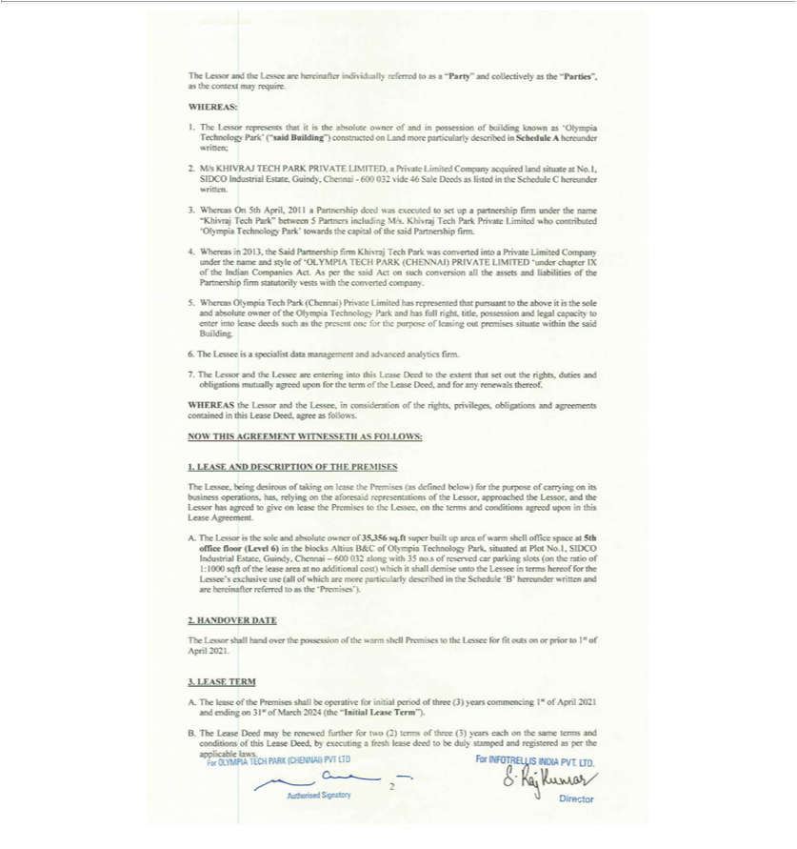

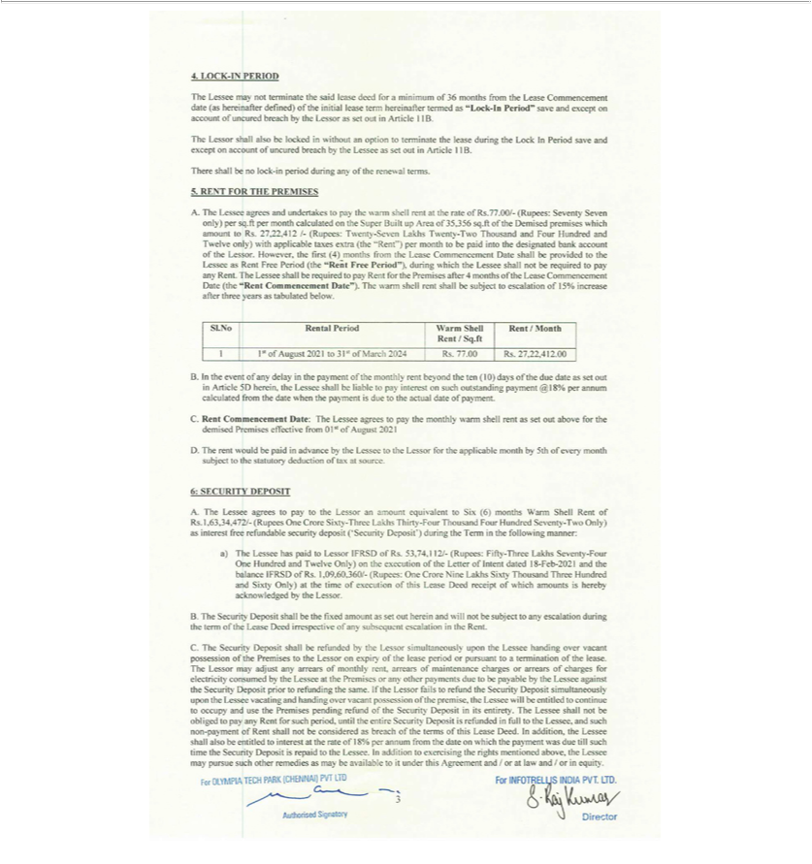

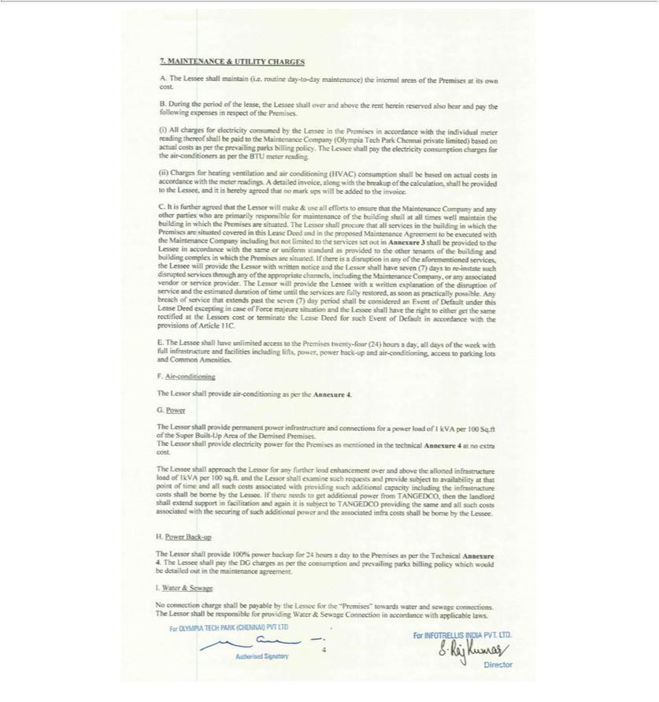

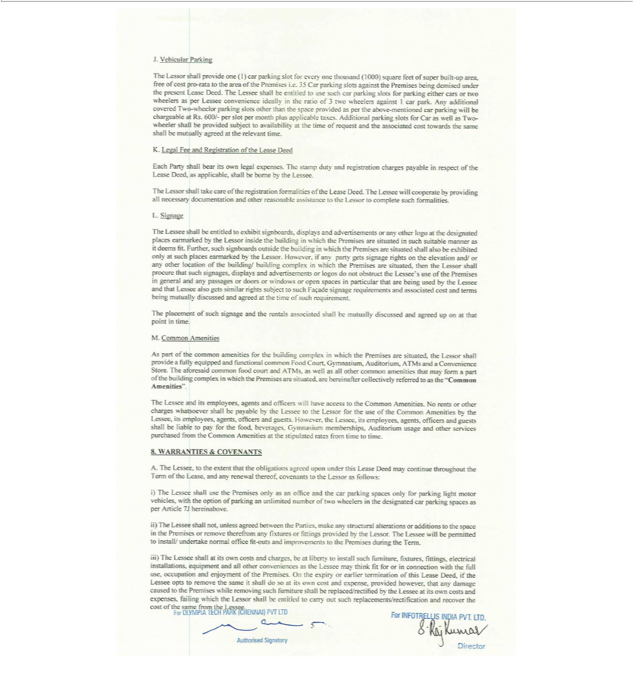

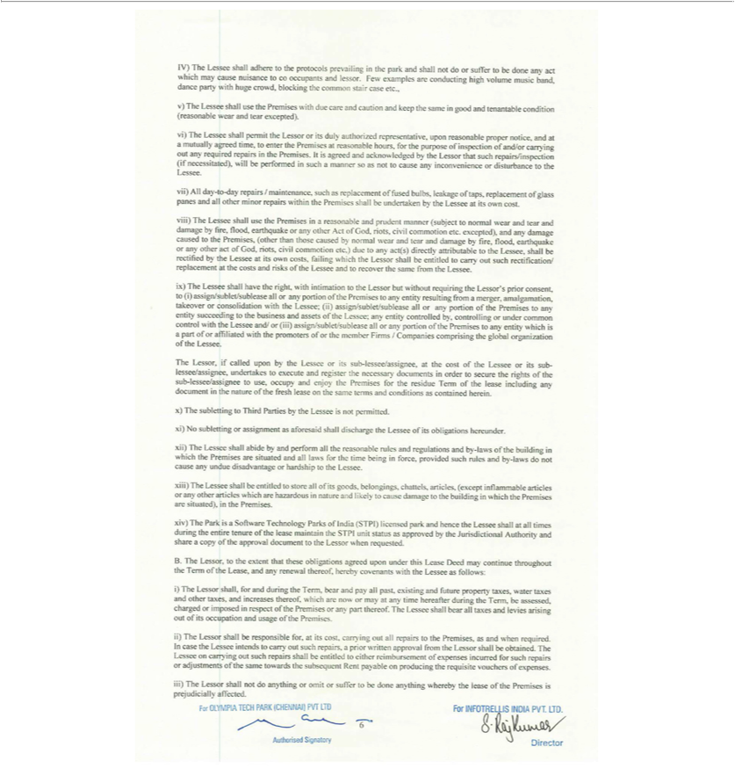

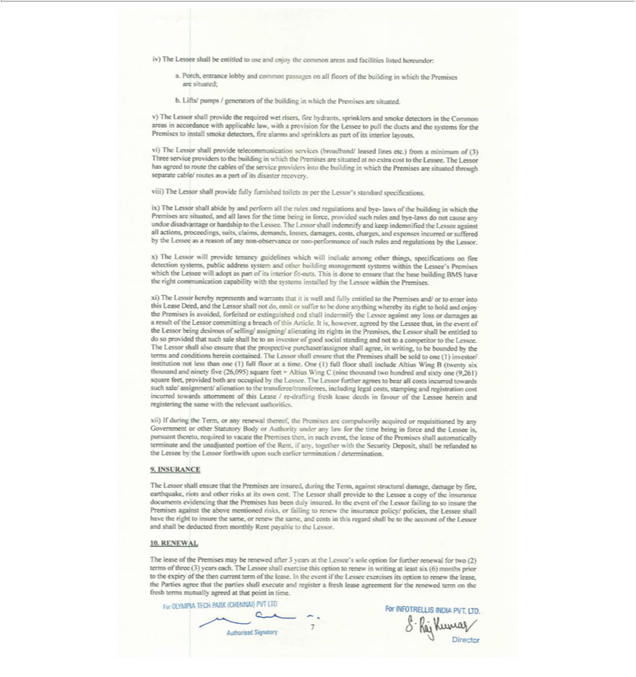

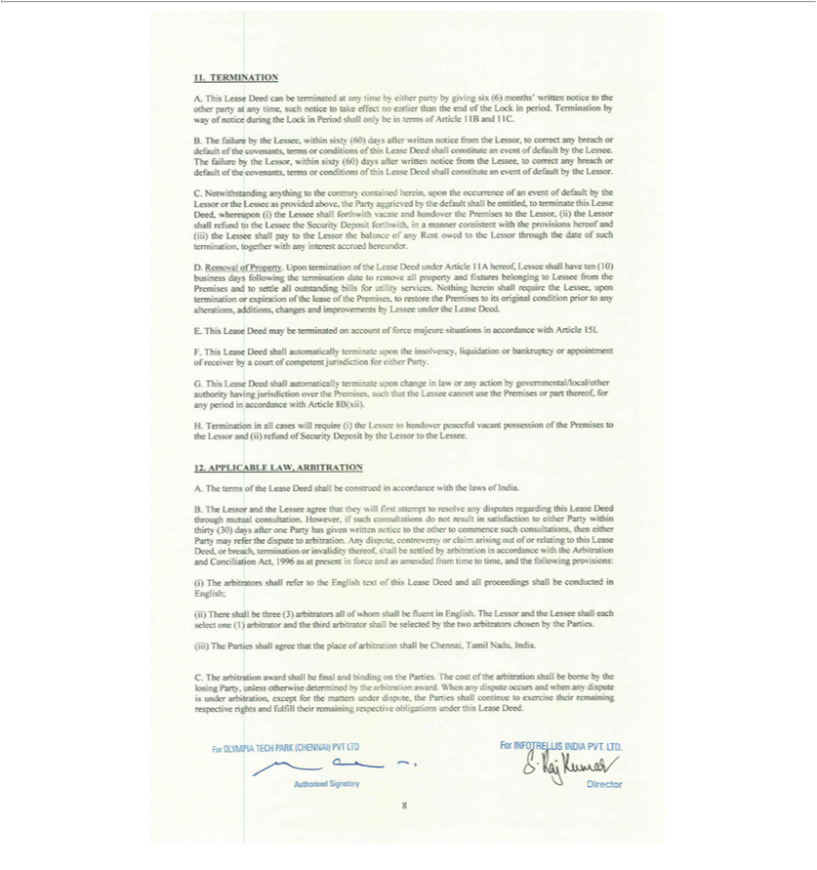

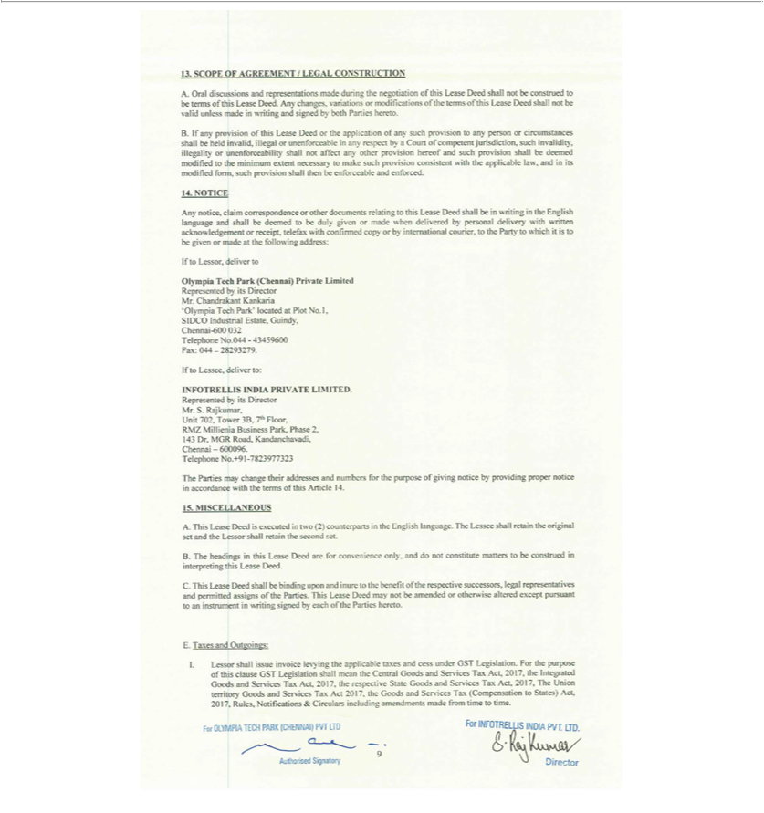

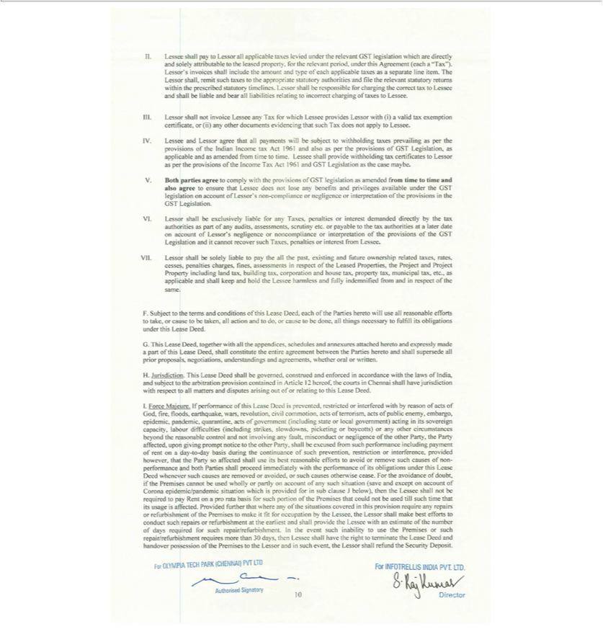

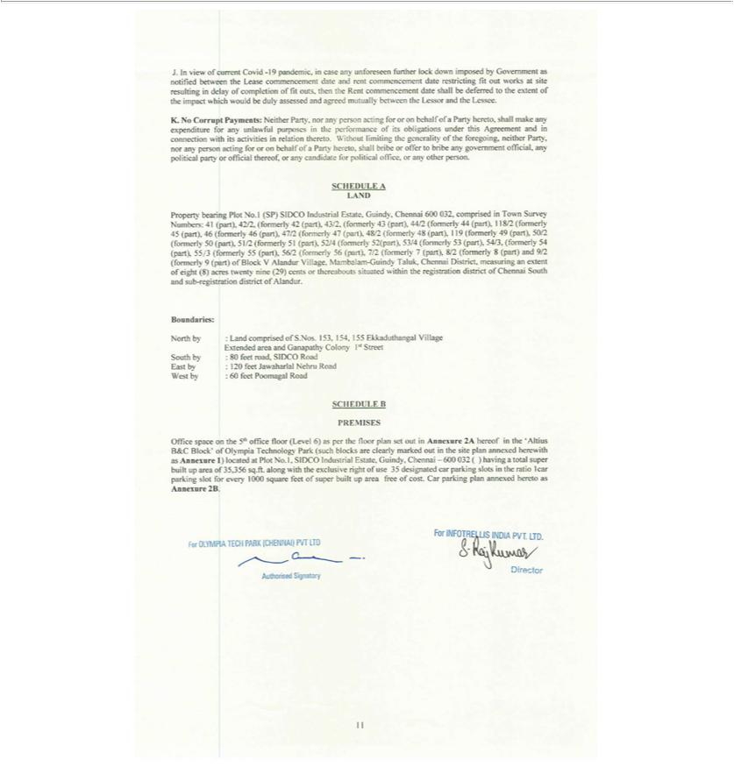

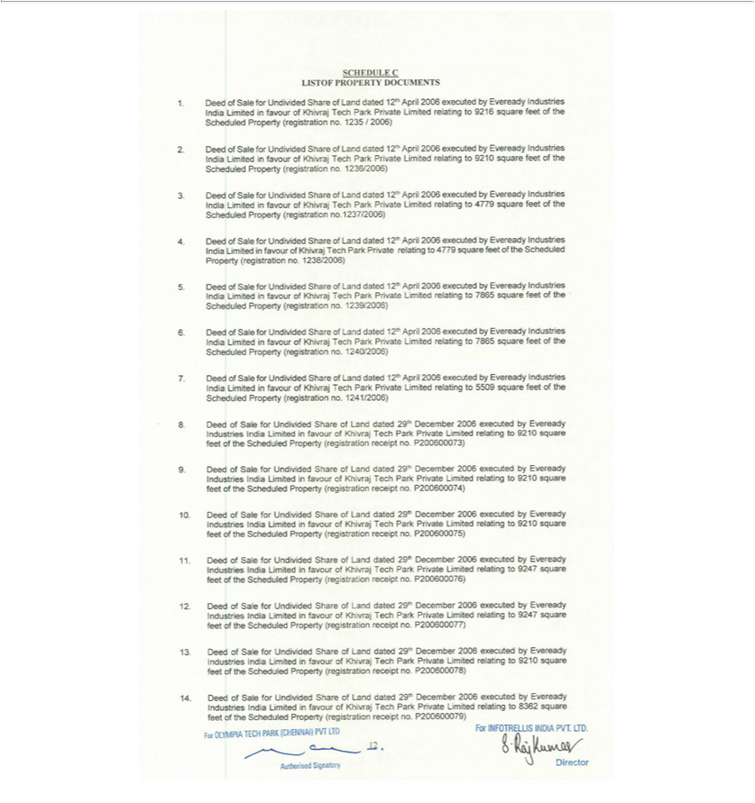

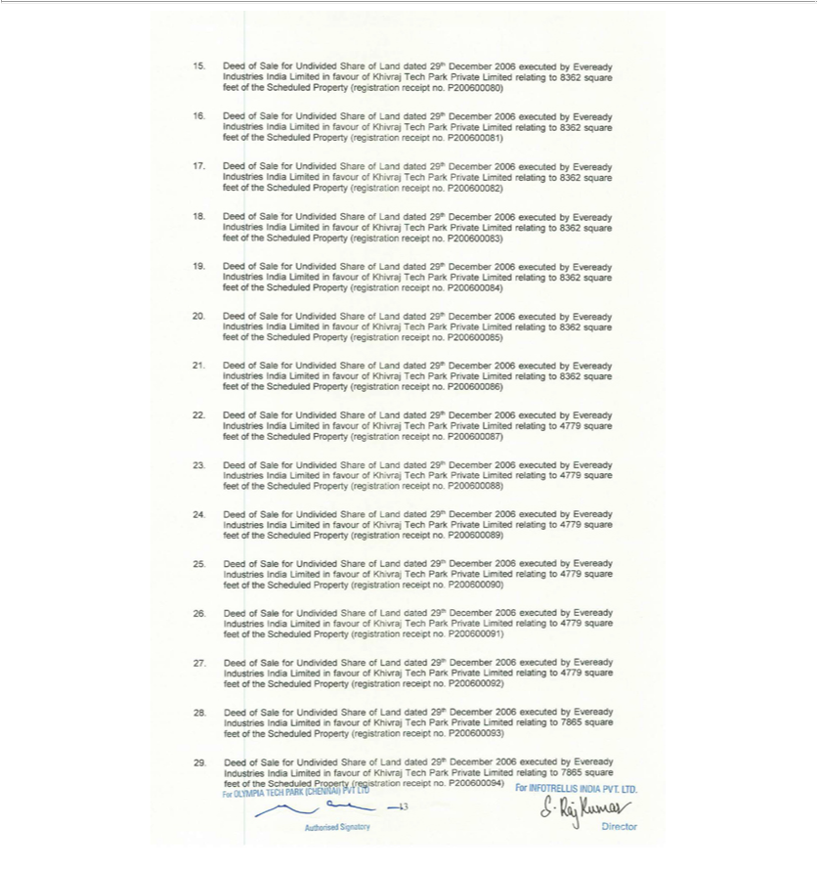

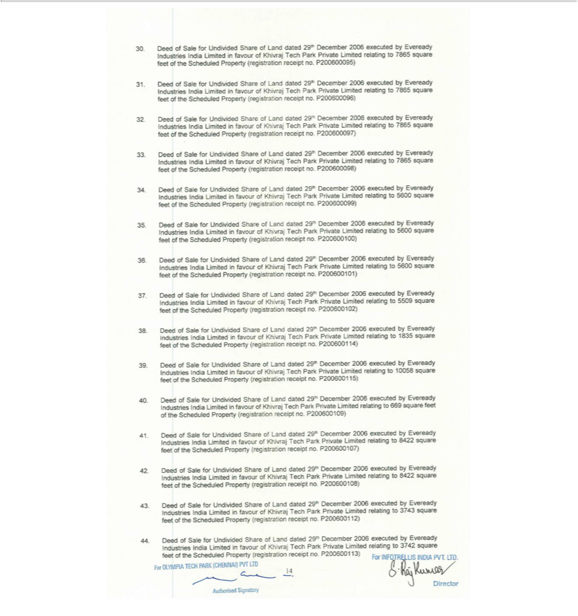

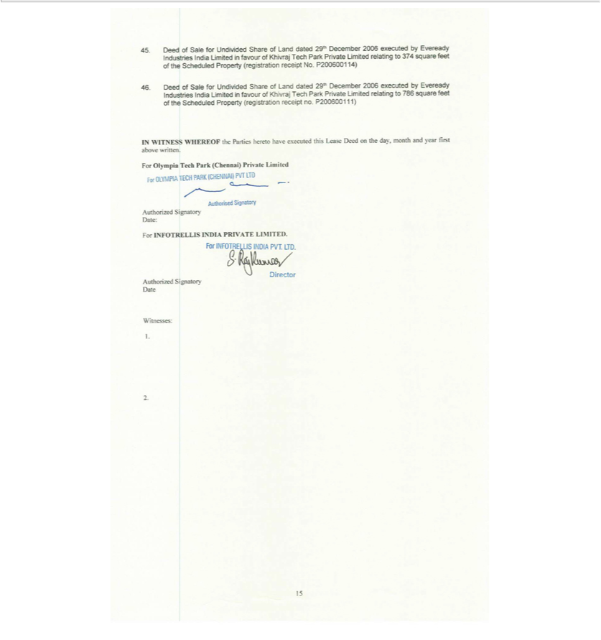

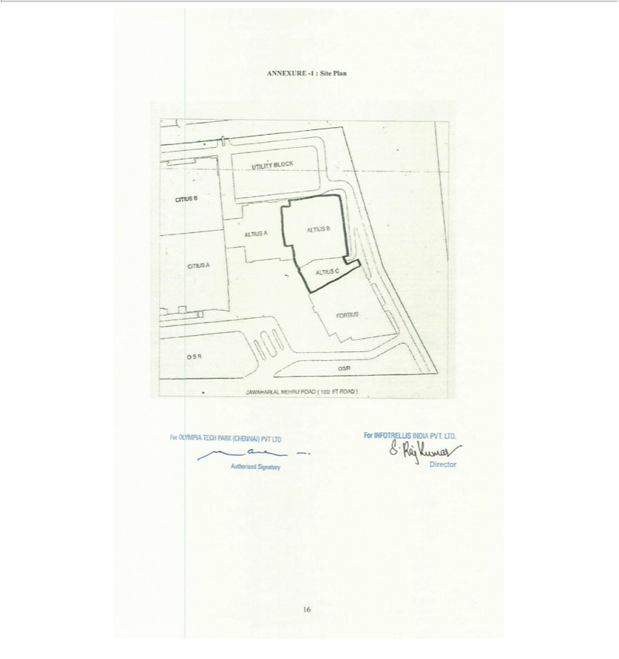

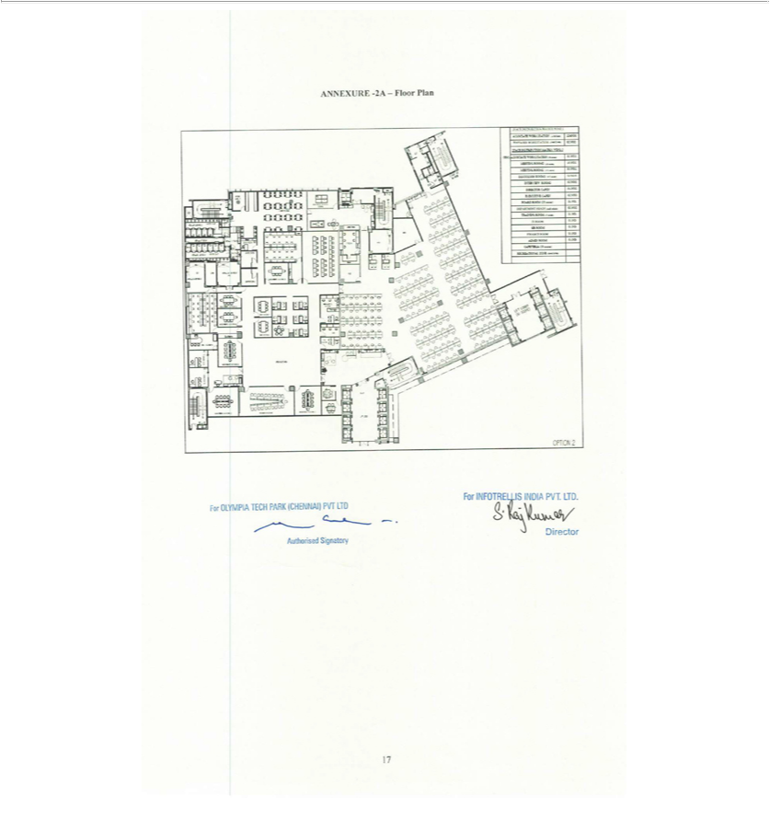

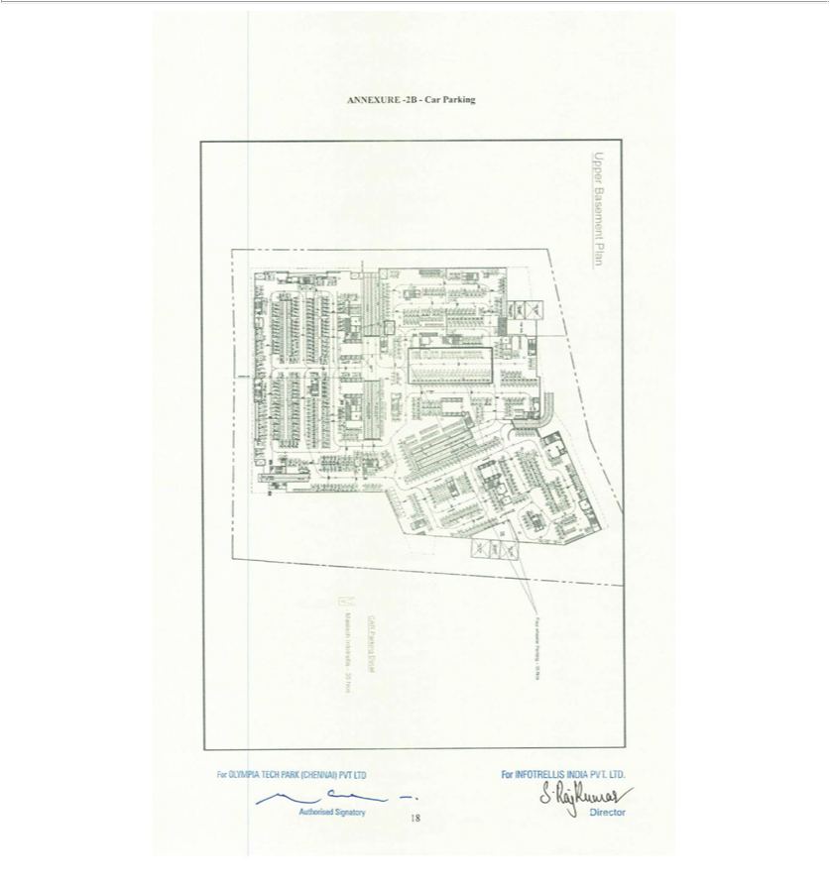

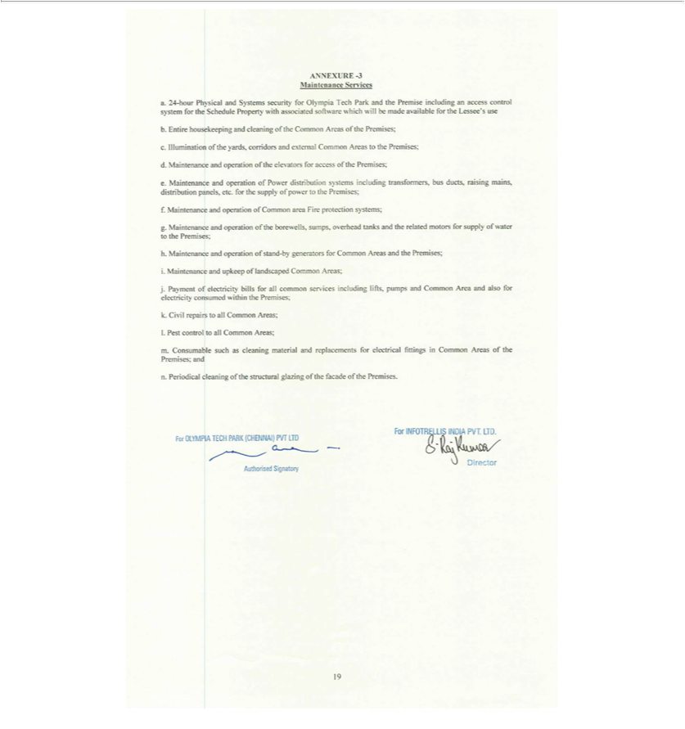

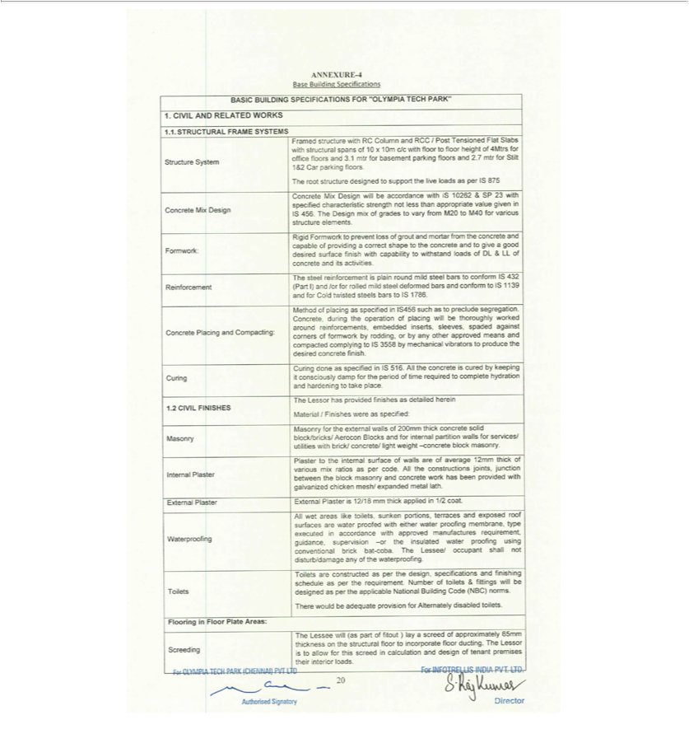

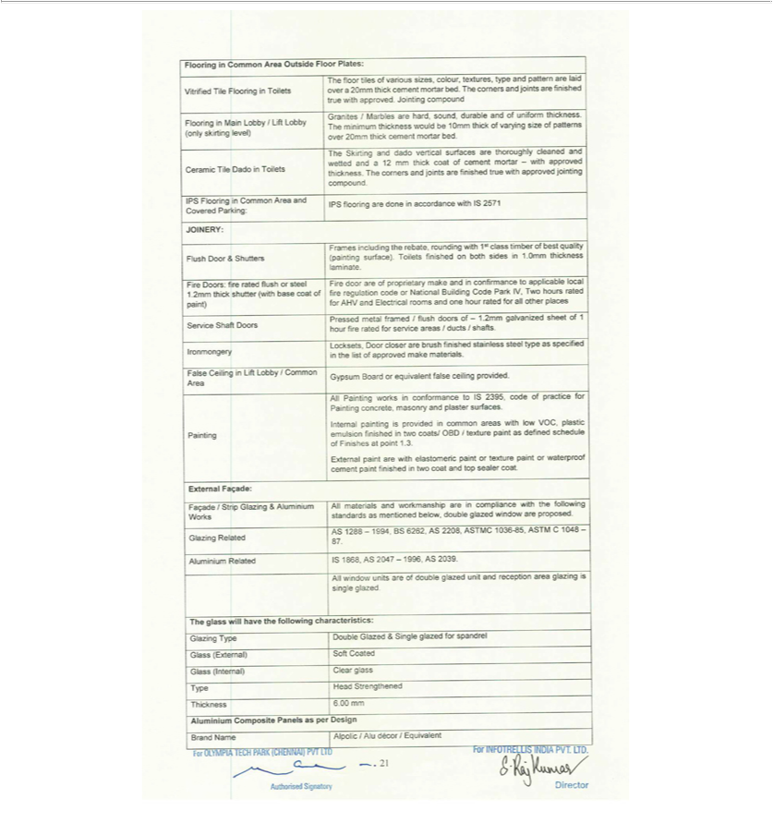

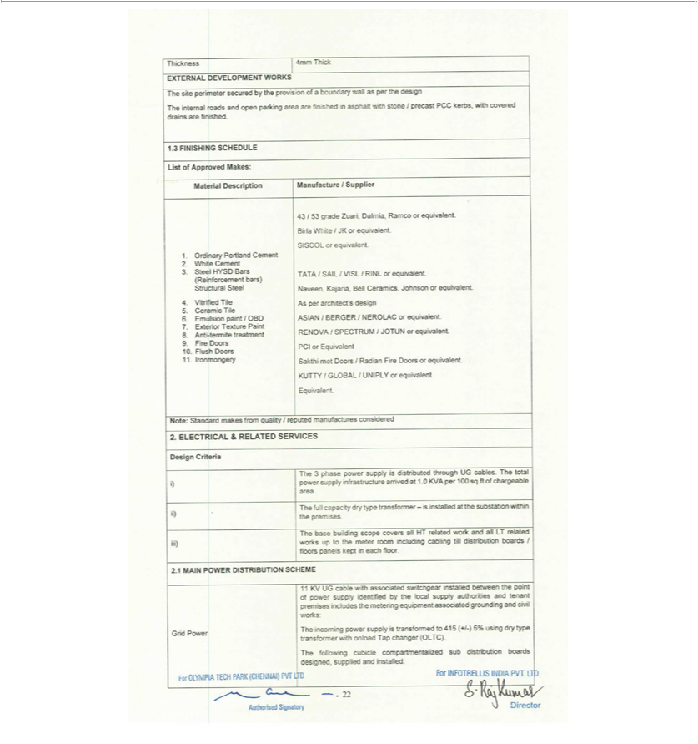

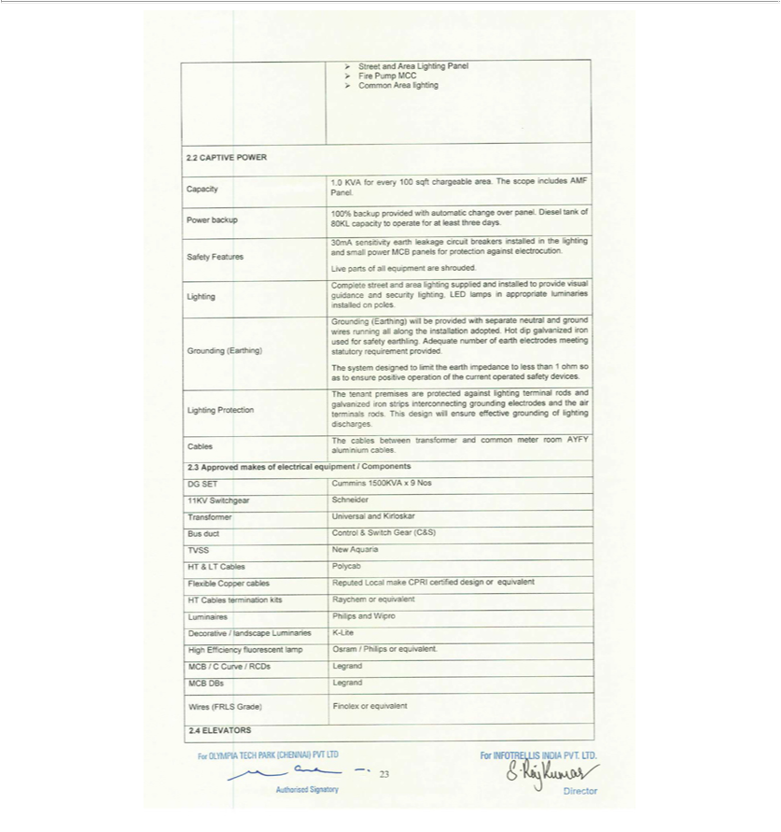

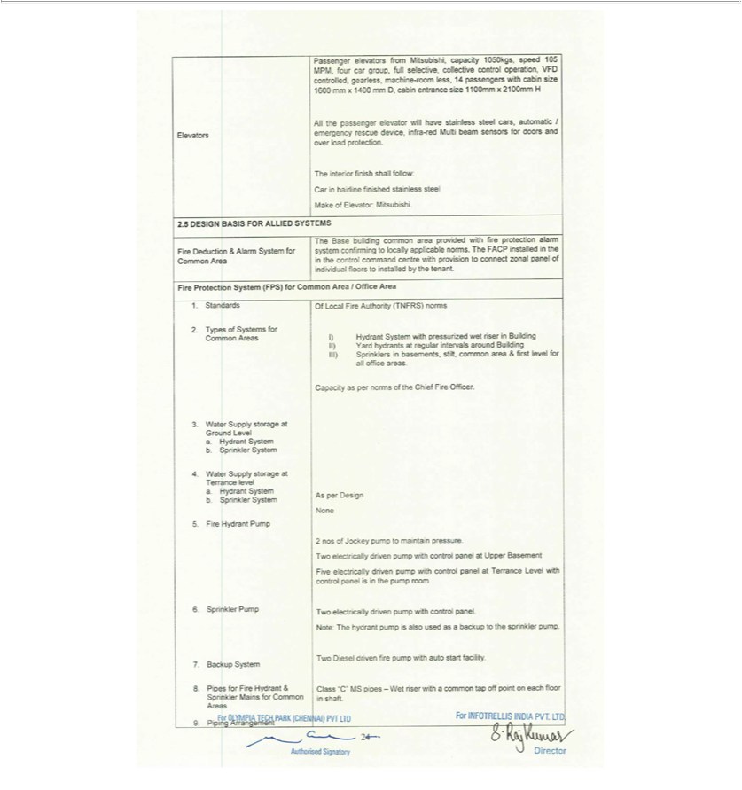

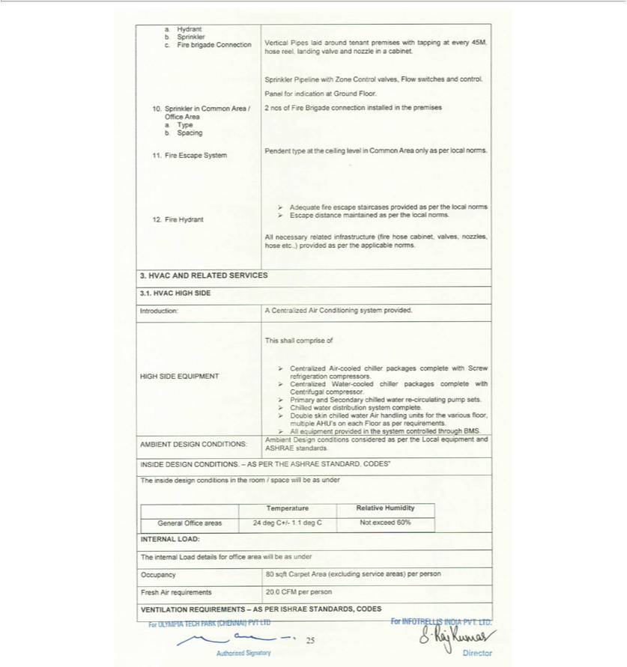

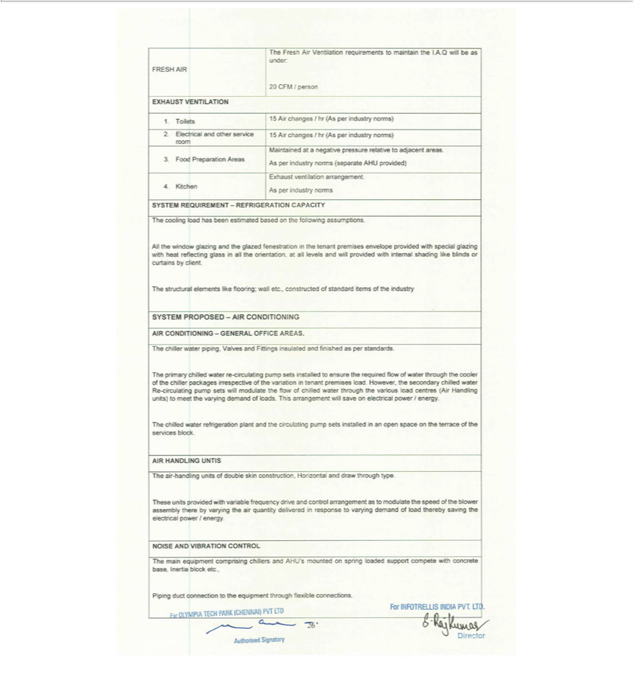

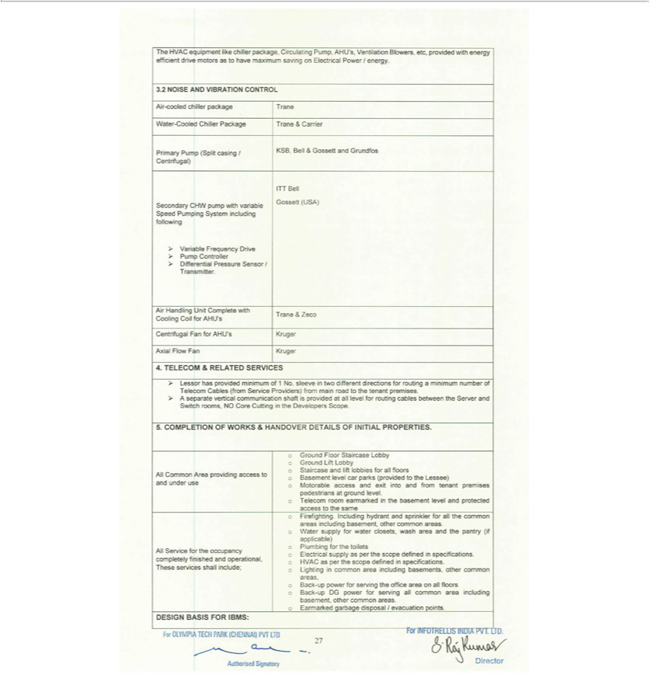

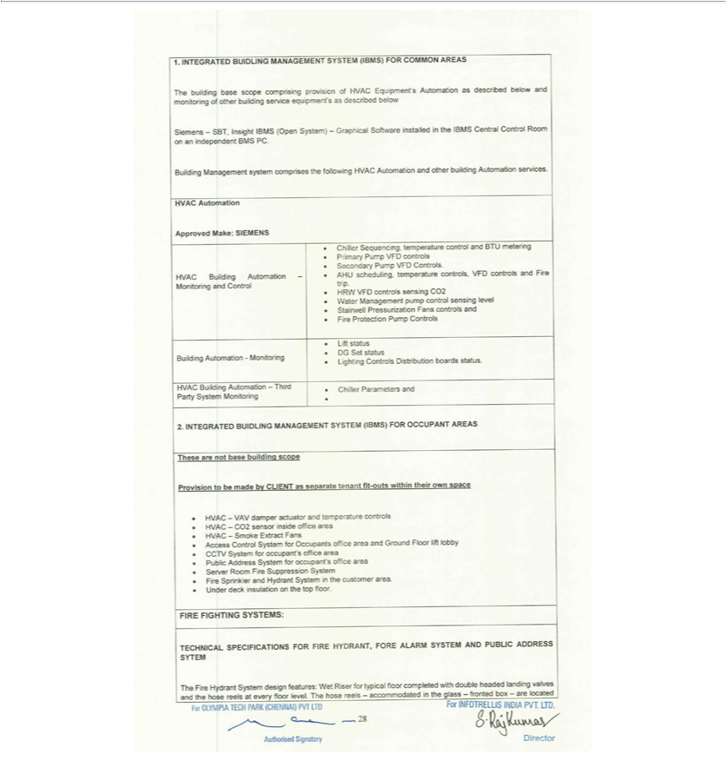

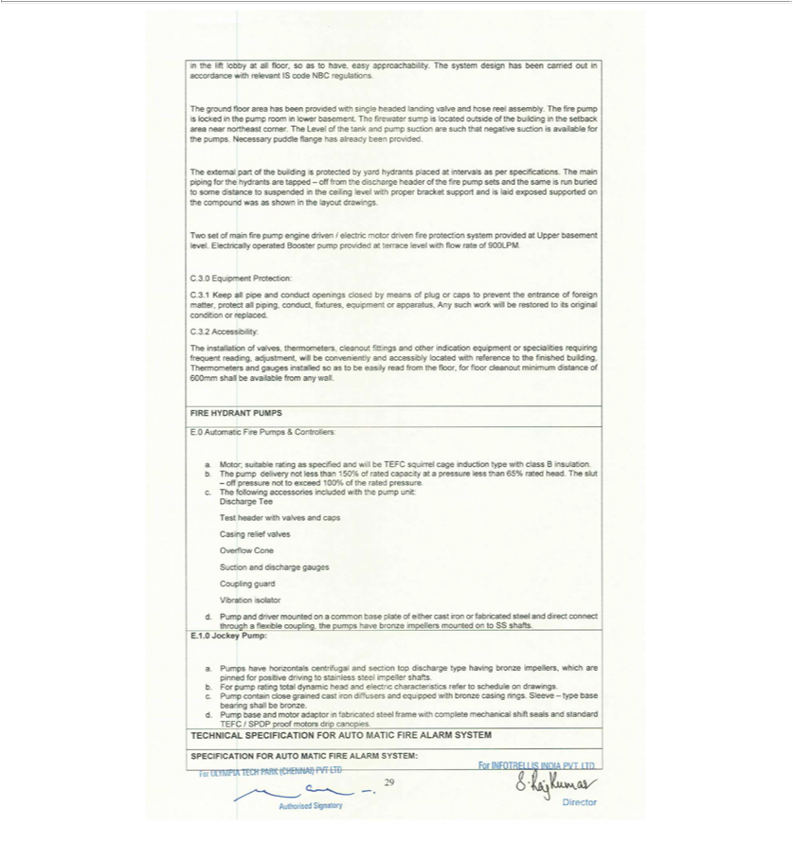

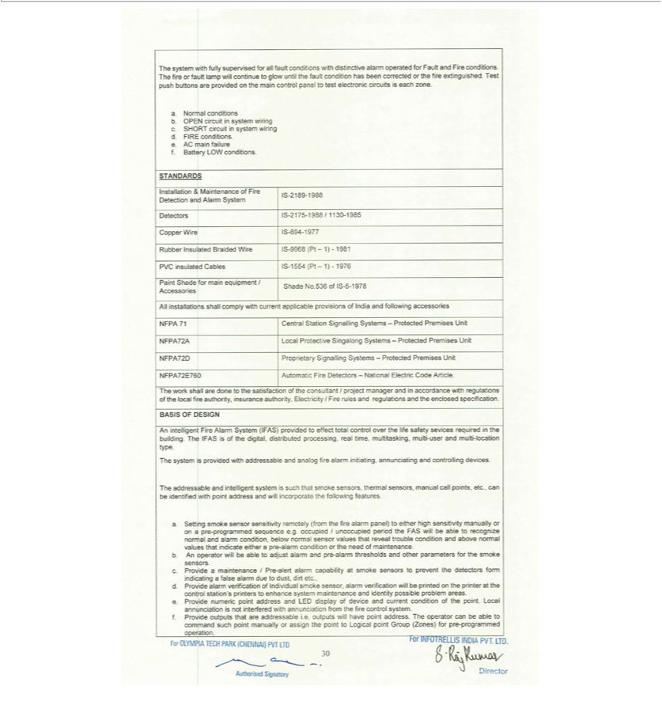

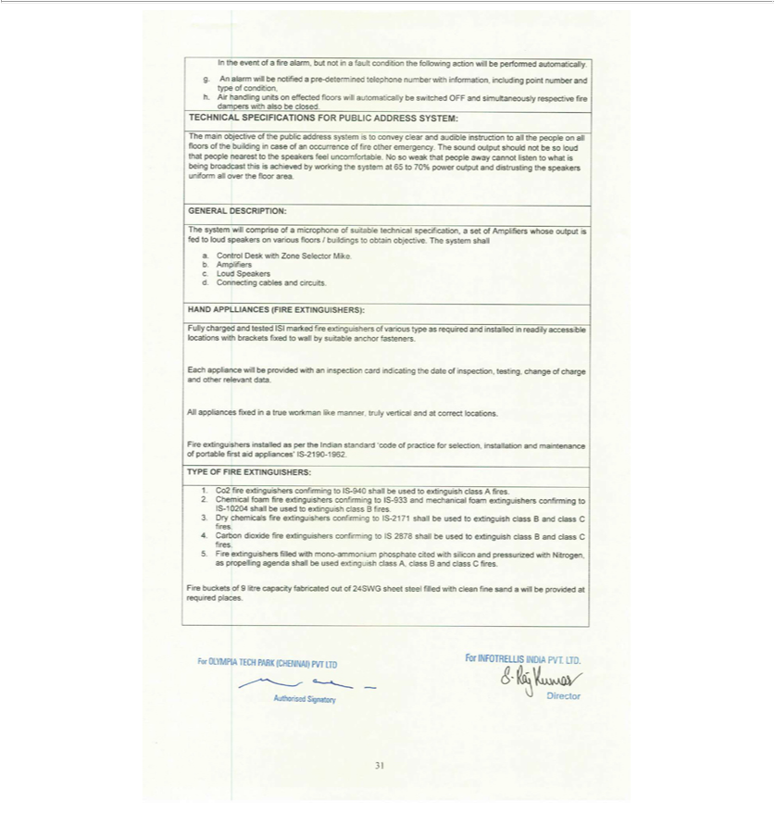

Exhibit 31.1

Certification Pursuant to Section 302 of the Sarbanes-Oxley Act of 2002 by Chief Executive Officer

I, Vivek Gupta, certify that:

- I have reviewed this report on Form 10-Q of Mastech Digital, Inc.;

- Based on my knowledge, this report does not contain any untrue statement of a material fact or omit to state a material fact necessary to make the statements made, in light of the circumstances under which such statements were made, not misleading with respect to the period covered by this report;

- Based on my knowledge, the financial statements, and other financial information included in this report, fairly present in all material respects the financial condition, results of operations and cash flows of the registrant as of, and for, the periods presented in this report;

- The registrant’s other certifying officer and I are responsible for establishing and maintaining disclosure controls and procedures (as defined in Exchange Act Rules 13a-15(e) and 15d-15(e)) and internal control over financial reporting (as defined in Exchange Act Rules 13a-15(f) and 15(d)-15(f)) for the registrant and have:

  - Designed such disclosure controls and procedures, or caused such disclosure controls and procedures to be designed under our supervision, to ensure that material information relating to the registrant, including its consolidated subsidiaries, is made known to us by others within those entities, particularly during the period in which this report is being prepared;

  - Designed such internal control over financial reporting, or caused such internal control over financial reporting to be designed under our supervision, to provide reasonable assurance regarding the reliability of financial reporting and the preparation of financial statements for external purposes in accordance with generally accepted accounting principles;

  - Evaluated the effectiveness of the registrant’s disclosure controls and procedures and presented in this report our conclusions about the effectiveness of the disclosure controls and procedures, as of the end of the period covered by this report based on such evaluation; and

  - Disclosed in this report any change in the registrant’s internal control over financial reporting that occurred during the registrant’s most recent fiscal quarter (the registrant’s fourth fiscal quarter in case of the annual report) that has materially affected, or is reasonably likely to materially affect, the registrant’s internal control over financial reporting; and

- The registrant’s other certifying officer and I have disclosed, based on our most recent evaluation of internal control over financial reporting, to the registrant’s auditors and the audit committee of the registrant’s board of directors (or persons performing the equivalent functions):

  - All significant deficiencies and material weaknesses in the design or operation of internal control over financial reporting which are reasonably likely to adversely affect the registrant’s ability to record, process, summarize and report financial information; and

  - Any fraud, whether or not material, that involves management or other employees who have a significant role in the registrant’s internal control over financial reporting.

MASTECH DIGITAL, INC.

Date: May 7, 2021 /S/ VIVEK GUPTA

Vivek Gupta

Chief Executive Officer

Exhibit 31.2

Certification Pursuant to Section 302 of the Sarbanes-Oxley Act of 2002 by Chief Financial Officer

I, John J. Cronin, Jr., certify that:

- I have reviewed this report on Form 10-Q of Mastech Digital, Inc.;

- Based on my knowledge, this report does not contain any untrue statement of a material fact or omit to state a material fact necessary to make the statements made, in light of the circumstances under which such statements were made, not misleading with respect to the period covered by this report;

- Based on my knowledge, the financial statements, and other financial information included in this report, fairly present in all material respects the financial condition, results of operations and cash flows of the registrant as of, and for, the periods presented in this report;

- The registrant’s other certifying officer and I are responsible for establishing and maintaining disclosure controls and procedures (as defined in Exchange Act Rules 13a-15(e) and 15d-15(e)) and internal control over financial reporting (as defined in Exchange Act Rules 13a-15(f) and 15(d)-15(f)) for the registrant and have:

  - Designed such disclosure controls and procedures, or caused such disclosure controls and procedures to be designed under our supervision, to ensure that material information relating to the registrant, including its consolidated subsidiaries, is made known to us by others within those entities, particularly during the period in which this report is being prepared;

  - Designed such internal control over financial reporting, or caused such internal control over financial reporting to be designed under our supervision, to provide reasonable assurance regarding the reliability of financial reporting and the preparation of financial statements for external purposes in accordance with generally accepted accounting principles;

  - Evaluated the effectiveness of the registrant’s disclosure controls and procedures and presented in this report our conclusions about the effectiveness of the disclosure controls and procedures, as of the end of the period covered by this report based on such evaluation; and

  - Disclosed in this report any change in the registrant’s internal control over financial reporting that occurred during the registrant’s most recent fiscal quarter (the registrant’s fourth fiscal quarter in case of the annual report) that has materially affected, or is reasonably likely to materially affect, the registrant’s internal control over financial reporting; and

- The registrant’s other certifying officer and I have disclosed, based on our most recent evaluation of internal control over financial reporting, to the registrant’s auditors and the audit committee of the registrant’s board of directors (or persons performing the equivalent functions):

  - All significant deficiencies and material weaknesses in the design or operation of internal control over financial reporting which are reasonably likely to adversely affect the registrant’s ability to record, process, summarize and report financial information; and

  - Any fraud, whether or not material, that involves management or other employees who have a significant role in the registrant’s internal control over financial reporting.

MASTECH DIGITAL, INC.

Date: May 7, 2021 /S/ JOHN J. CRONIN, JR.

John J. Cronin, Jr.

Chief Financial Officer

Exhibit 32.1

Certification Pursuant to 18 U.S.C. Section 1350,

As Adopted Pursuant to

Section 906 of the Sarbanes-Oxley Act of 2002

In connection with the Quarterly Report of Mastech Digital, Inc. (the “Company”) on Form 10-Q for the quarter ended March 31, 2021, as filed with the Securities and Exchange Commission on the date hereof (the “Report”), I, Vivek Gupta, Chief Executive Officer of the Company, certify, pursuant to 18 U.S.C. § 1350, as adopted pursuant to § 906 of the Sarbanes-Oxley Act of 2002, that, to my knowledge:

- The Report fully complies with the requirements of Section 13(a) or 15(d) of the Securities Exchange Act of 1934, as amended; and

- The information contained in the Report fairly presents, in all material respects, the financial condition and results of operations of the Company.

/S/ VIVEK GUPTA

Vivek Gupta

Chief Executive Officer

Date: May 7, 2021

Exhibit 32.2

Certification Pursuant to 18 U.S.C. Section 1350,

As Adopted Pursuant to

Section 906 of the Sarbanes-Oxley Act of 2002

In connection with the Quarterly Report of Mastech Digital, Inc. (the “Company”) on Form 10-Q for the quarter ended March 31, 2021, as filed with the Securities and Exchange Commission on the date hereof (the “Report”), I, John J. Cronin, Jr. Chief Financial Officer of the Company, certify, pursuant to 18 U.S.C. § 1350, as adopted pursuant to § 906 of the Sarbanes-Oxley Act of 2002, that, to my knowledge:

- The Report fully complies with the requirements of Section 13(a) or 15(d) of the Securities Exchange Act of 1934, as amended; and

- The information contained in the Report fairly presents, in all material respects, the financial condition and results of operations of the Company.

/S/ JOHN J. CRONIN, JR.

John J. Cronin, Jr.

Chief Financial Officer

Date: May 7, 2021

